JSP Fundamental
A couple of students have asked about configuring the connection pool for Production use.
Here are three resources that can help you with this configuration:
Configuring jdbc-pool for high-concurrency
- https://my.oschina.net/shipley/blog/519449
--
Real-World Tips and Tricks to Tune Apache Tomcat for High Performance
https://www.eginnovations.com/blog/tomcat-performance-tuning/
--
Optimal number of connections in connection pool
- http://stackoverflow.com/questions/1208077/optimal-number-of-connections-in-connection-pool

A couple of students have asked about configuring the connection pool for Production use.
Here are three resources that can help you with this configuration:
Configuring jdbc-pool for high-concurrency
- https://my.oschina.net/shipley/blog/519449
--
Real-World Tips and Tricks to Tune Apache Tomcat for High Performance
https://www.eginnovations.com/blog/tomcat-performance-tuning/
--
Optimal number of connections in connection pool
- http://stackoverflow.com/questions/1208077/optimal-number-of-connections-in-connection-pool

A couple of students have asked about configuring the connection pool for Production use.
Here are three resources that can help you with this configuration:
Configuring jdbc-pool for high-concurrency
- https://my.oschina.net/shipley/blog/519449
--
Real-World Tips and Tricks to Tune Apache Tomcat for High Performance
https://www.eginnovations.com/blog/tomcat-performance-tuning/
--
Optimal number of connections in connection pool
- http://stackoverflow.com/questions/1208077/optimal-number-of-connections-in-connection-pool

A couple of students have asked about configuring the connection pool for Production use.
Here are three resources that can help you with this configuration:
Configuring jdbc-pool for high-concurrency
- https://my.oschina.net/shipley/blog/519449
--
Real-World Tips and Tricks to Tune Apache Tomcat for High Performance
https://www.eginnovations.com/blog/tomcat-performance-tuning/
--
Optimal number of connections in connection pool
- http://stackoverflow.com/questions/1208077/optimal-number-of-connections-in-connection-pool

1) Web Application

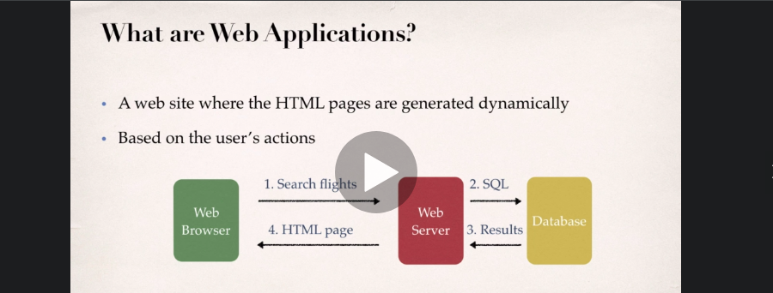
Different technologies from which we can generate JSP are as follows: PHP , .NET , JSP , Servlet

2) JSP and Servlet

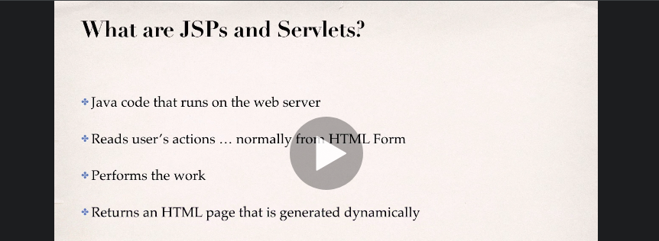
- On web server JSP and Servlet used to there , which perform key componets of Java EE.

- MVC Frameworks are Spring , Struts , etc still uses JSP and servlet .

The Model-View-Controller(MVC) is an architectural pattern that separates an application into three main logical components: the model, the view, and the controller. ... MVC is one of the most frequently used industry-standard web development framework to create scalable and extensible projects.

3 ) Required softwares

a ) Java Application Server
- Apache Tomcat , Oracle Weblogic , WebSphere , WildFly , GlassFish , Geronimo

b ) Java IDE
- Eclipse , NetBeans , BlueJ, Visual Studio

c ) Java Development Kit ( JDK not JRE )

Don’t get confused as we are going to discuss all of them one by one.
1. JDK (Java Development Kit) is a Kit that provides the environment to develop and execute(run) the Java program. JDK is a kit(or package) that includes two things
- Development Tools(to provide an environment to develop your java programs)
- JRE (to execute your java program).
2. JRE (Java Runtime Environment) is an installation package that provides an environment to only run(not develop) the java program(or application)onto your machine. JRE is only used by those who only want to run Java programs that are end-users of your system.
3. JVM (Java Virtual Machine) is a very important part of both JDK and JRE because it is contained or inbuilt in both. Whatever Java program you run using JRE or JDK goes into JVM and JVM is responsible for executing the java program line by line, hence it is also known as an interpreter.

4 ) Installation steps for Tomcat
a ) First method of installation ( Not preferred method for installation )
- sudo apt update – For updating Repository
- sudo apt-cache search tomcat – Will show all availble package for download
- sudo apt install tomcat9 tomcat9-admin – For installation
- ss – ltn – For verification purpose ( Default port is 8080 )
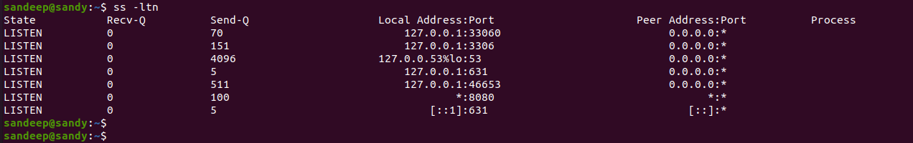
- sudo systemctl enable/disable tomcat9 – For enabling and disabling tomcat
- sudo ufw allow from any to any port 8080 proto tcp – Command for checking firewall rules updated for mentioned port
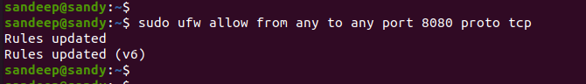
- For checking Application
Application URL : http://localhost:8080/ or http://127.0.0.1:8080/

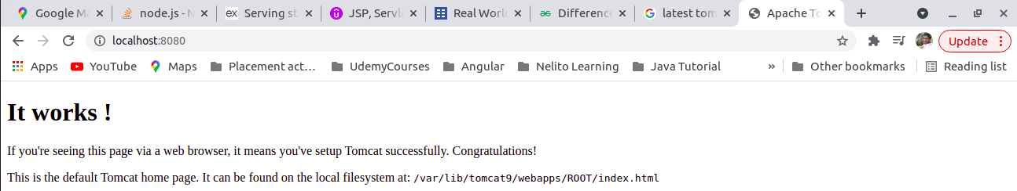
b) Second method for the installation ( Most Effective Method )
- Download tomcat from browser
- Extract downloaded folder
- Go to home -> make new folder ‘web’ -> cut Apache folder in it
- Go to .bashrc file -> vi .bashrc and give catalina_home and java home path
- CTRL + L - > will navigate to address bar path
export CATALINA_HOME=/home/sandeep/web/apache-tomcat-9.0.54
export JAVA_HOME=/usr/lib/jvm/java-8-openjdk-amd64
- Go to path where apache installed
/home/sandeep/web/apache-tomcat-9.0.54/
- Run the startup.sh file using command
File location : /home/sandeep/web/apache-tomcat-9.0.54/bin
sh startup.sh
- To cross check tomcat started or not
firefox localhost:8080
start chrome localhost:8080

----------------------- Default page of Apache tomcat server ----------------------------------------

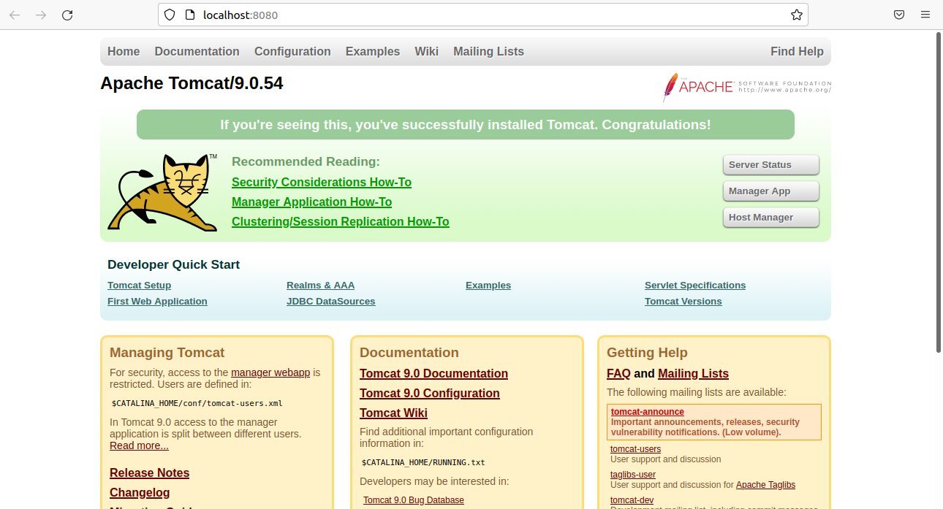
- To change default username and password
Click on Manager App - > cancel - > copy below line from browser & paste into tomcat-users.xml
<role rolename="manager-gui"/>
<user username="tomcat" password="s3cret" roles="manager-gui"/>
conf - > tomcat-users.xml
- In order to affect changes restart tomcat server
run shutdown.sh and startup.sh
- Click on Manager App -> Give username and password
Username : admin
Password : password
- Interface will look like this
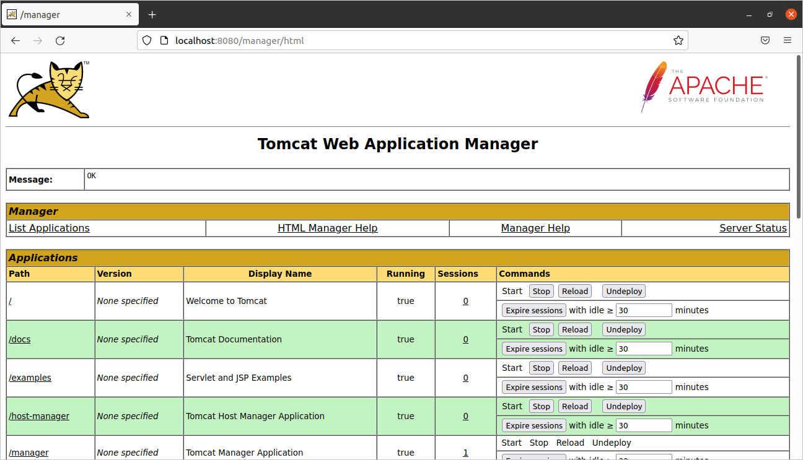

5 ) Connecting Tomcat and Eclipse
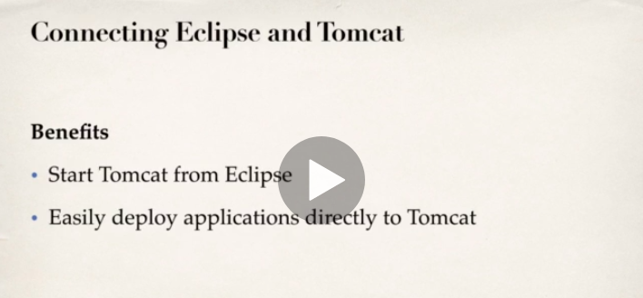
- Click on new server connection
- Give full tomcat installation directory path
/home/sandeep/web/apache-tomcat-9.0.54/
- Click on Finish
- Below screenshot confirm Eclipse estalblished tomcat environment

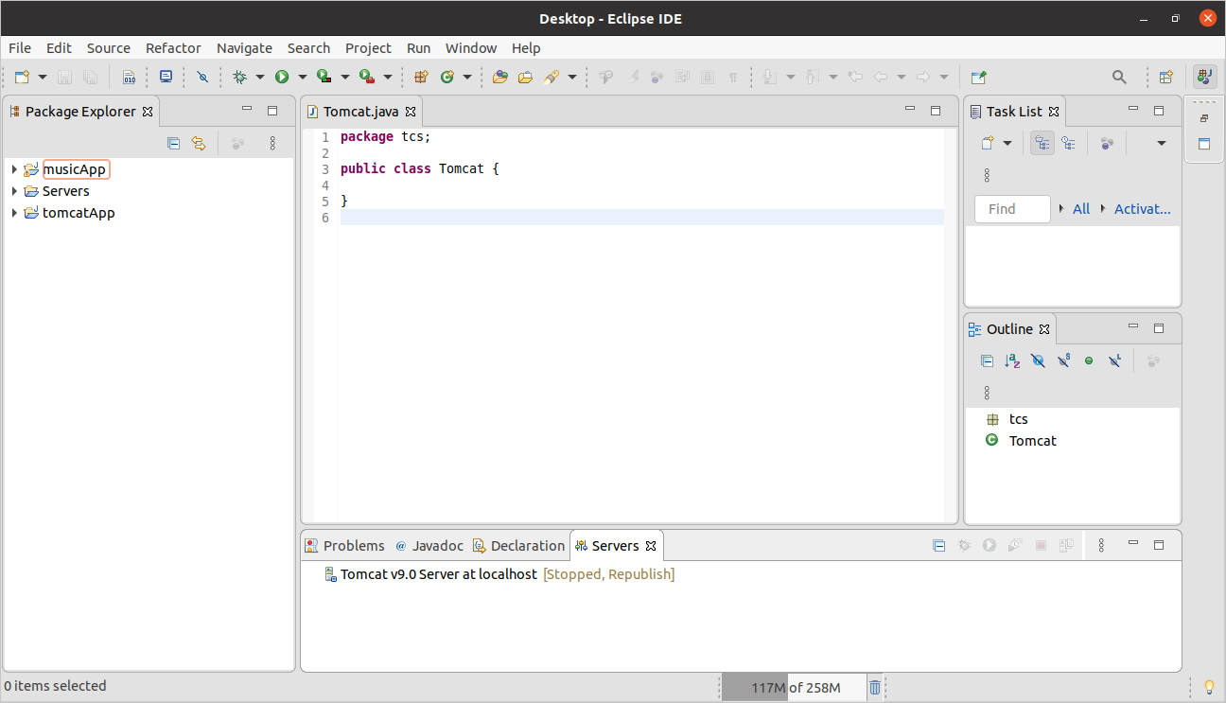
- Conncection established successfully
6 ) JSP Fundamentals

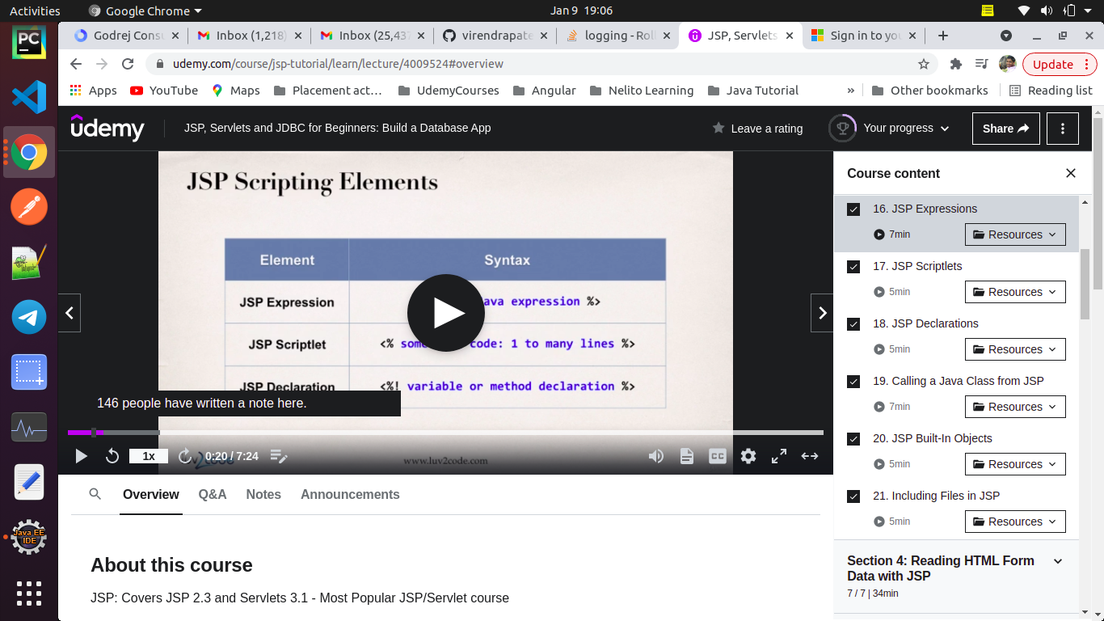

a) Hello World
- JSP File generated by some java code sprinkled in it.
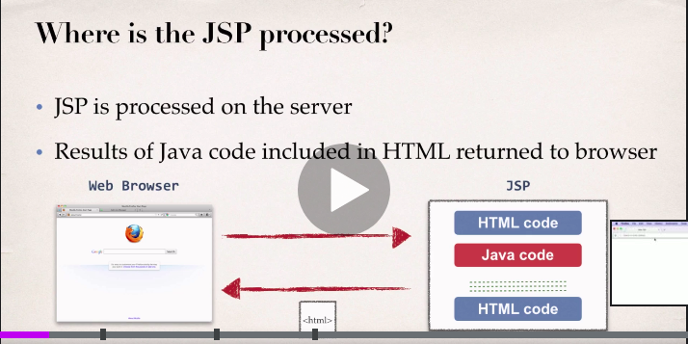
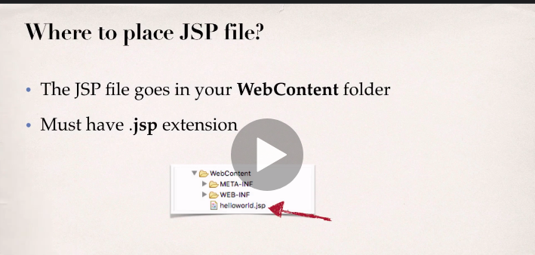
- Basically a HTML page , some java code sprinkled on it.
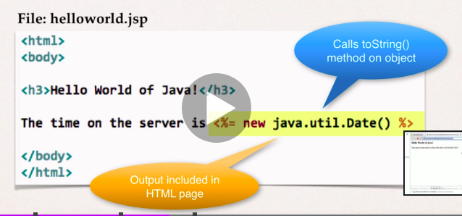
- Dynamin Web Project path
File -> others -> Web -> Dynamic Web project
( Note: Dynamic web project works fine with Java EE Edition )
- To removce eclipse from Ubuntu , it’s entries are there in
a) Home directory
sudo apt-get autoremove --purge eclipse
b) Main folder
rm -rfv .eclipse
c) Desktop
sudo snap remove eclipse

locate eclipse.desktop
- To install and launch Eclipse EE in ubuntu
/home/sandeep/Downloads/eclipse-jee-2021-09-R-linux-gtk-x86_64
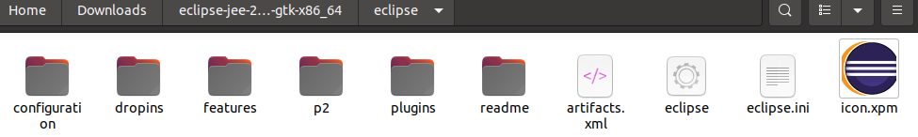
Double click on eclipse
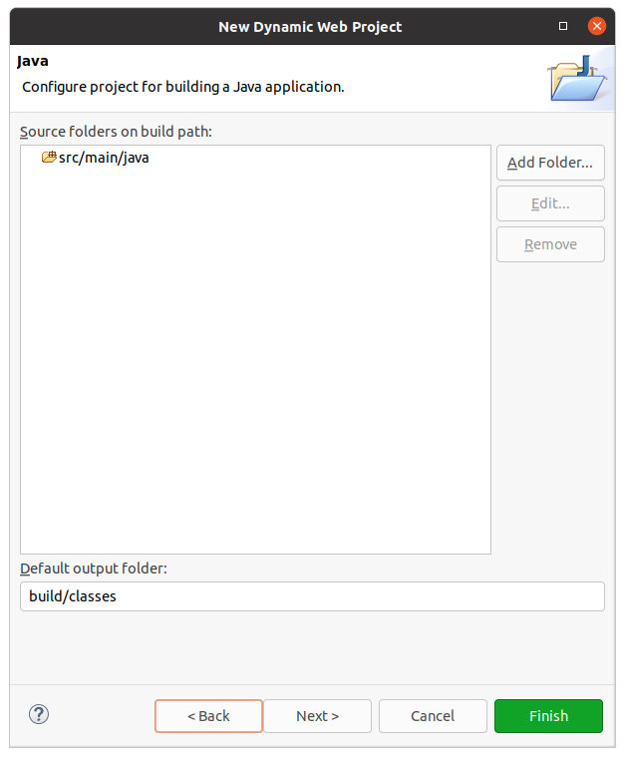
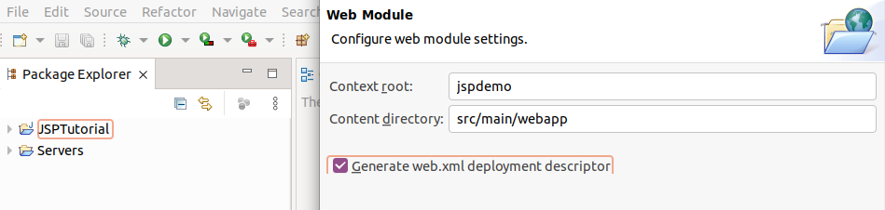
b) JSP Expressions
JSP project path :
/home/sandeep/Documents/jspdemo/src/main/webapp
( Note : For source code refere Eclipse JEE )

Output :

c) JSP Scriptlet

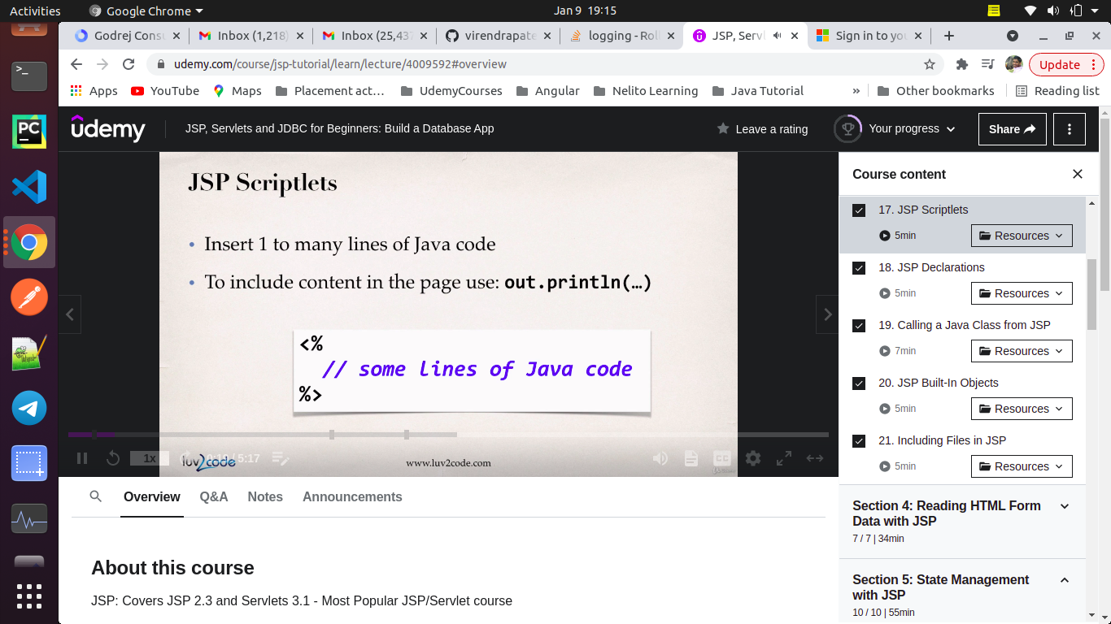
- Insert 1 to many lines of Java code
- To include content in the page use : out.println( )
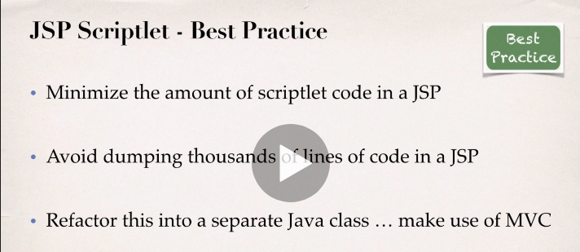
Output:
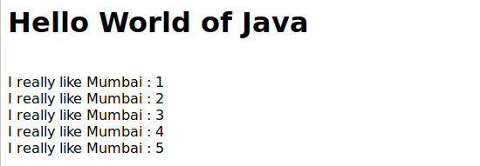
d) JSP Declarations
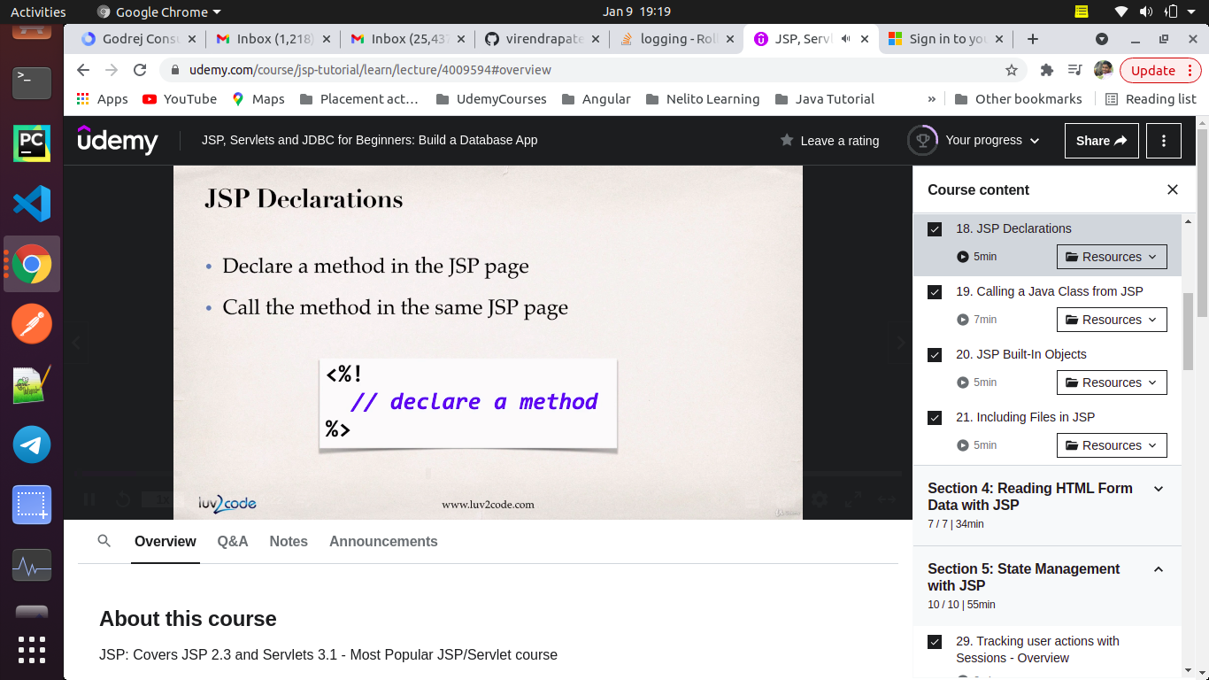
- Declare a method in JSP page
- Call a method in same page
- Minimize the no of declarations in JSP
- Avoid dumping thousands of lines of code in jsp
Output:
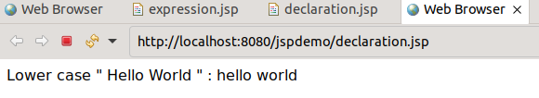

e ) Calling a JSP method
How to call a method : we have to give full classified name i.e. packagename.classname.methodname()
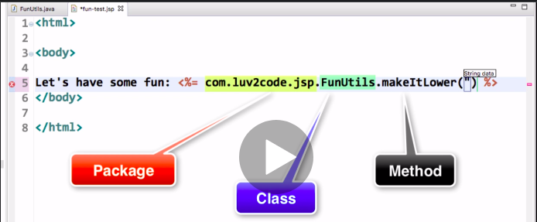
Note: To import classes and additional librabry in JSP files use @ in syntax .
<%@ ------ %>
f ) Built in Objects in JSP
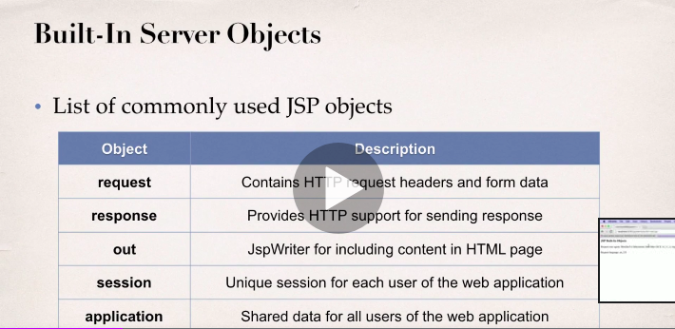
- Browser send request to JSP page , for that request JSP send a response to browser .
- First question what to include in request and response ( req and res me kya bhejna hai ) .
- For eg . Browser info , OS version , Language supported , etc . To get all these information we have to use built in objects.
- IDE request
Request user-agent : Mozilla/5.0 (X11; Ubuntu; Linux x86_64) AppleWebKit/605.1.15 (KHTML, like Gecko) Version/15.0 Safari/605.1.15
Request Language : en_IN
- Chrome request
Request user-agent : Mozilla/5.0 (X11; Linux x86_64) AppleWebKit/537.36 (KHTML, like Gecko) Chrome/89.0.4389.90 Safari/537.36
Request Language : en_GB
- Mozilla request
Request user-agent : Mozilla/5.0 (X11; Ubuntu; Linux x86_64; rv:94.0) Gecko/20100101 Firefox/94.0
Request Language : en_US
g ) Including Files in JSP
Basically to include other files ( html and jsp ) into main JSP file . These other files include header and footer.
7 ) Reading HTML form Data with JSP
- Review HTML form
- Build HTML form
- Reading Form Data with JSPs
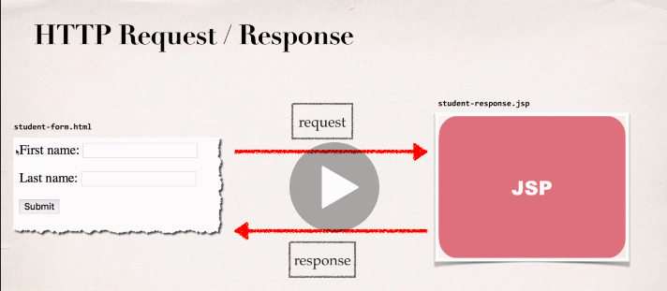
- action : property/attribute of html shows where to send html page .
- value : property/attribute indicate name to be display on button.
- name : property/attribute name is form for JSP page for reading form data.
a) Difference between radio and checkbox

7) State Management with JSP
a) Session Tracking with JSP
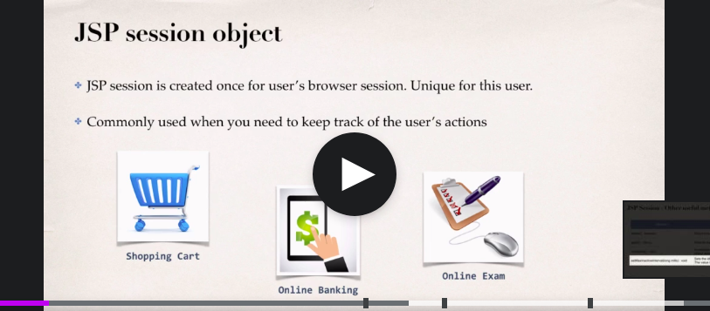
fjasd
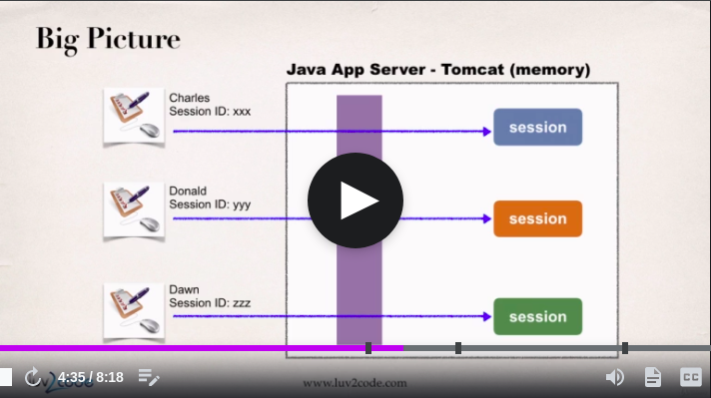
ssdf
b) Cookies
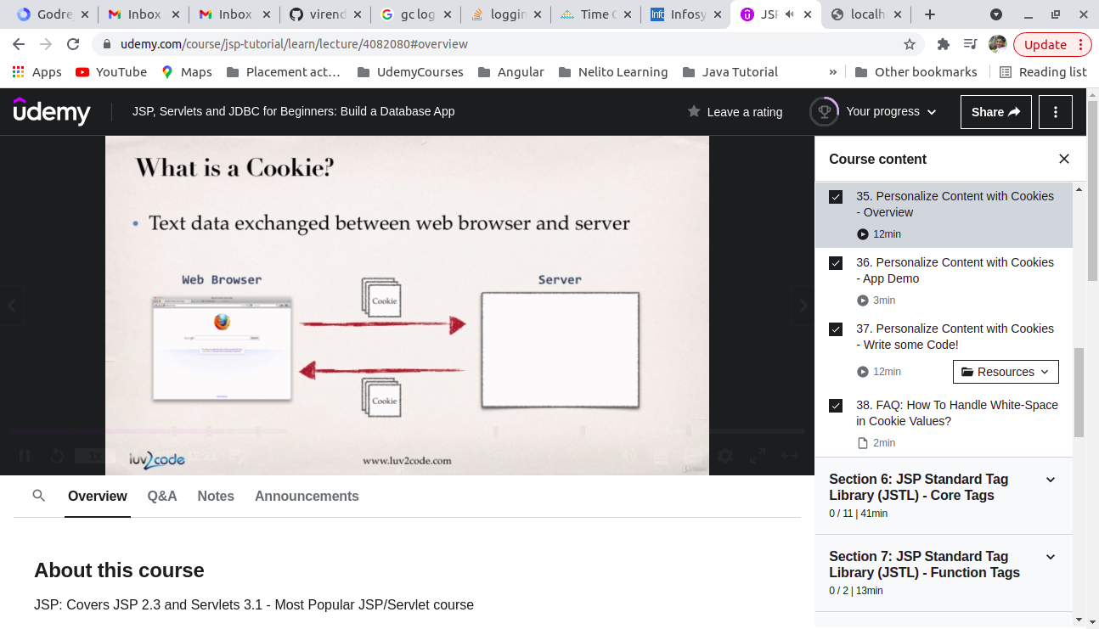
gf
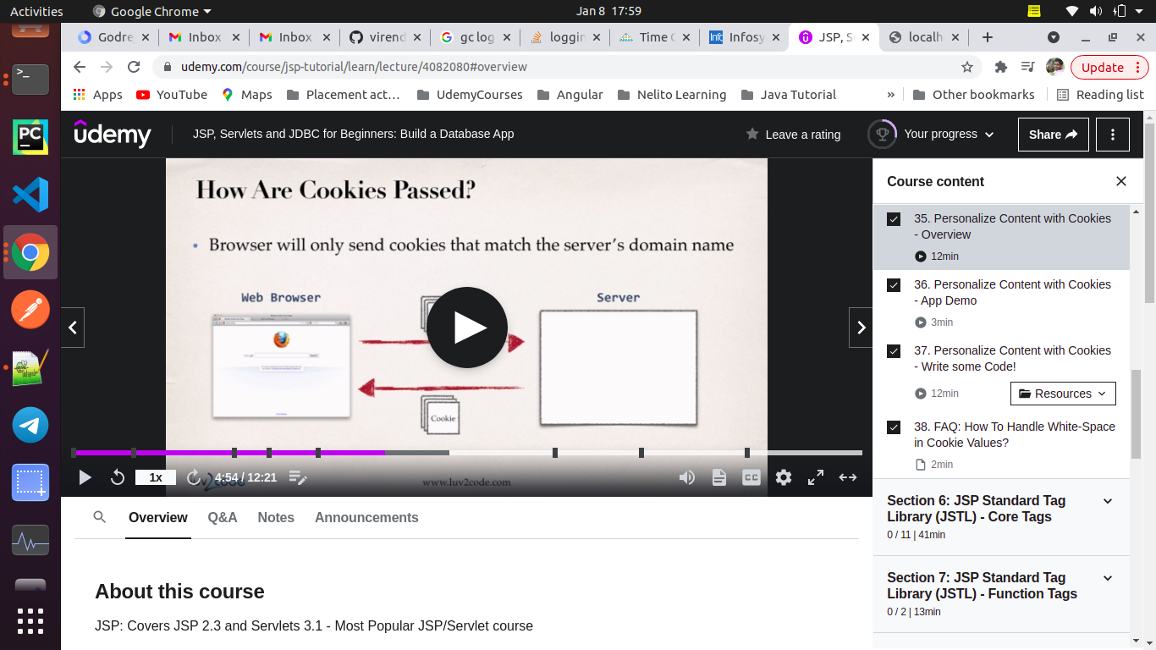
kkj
ytt
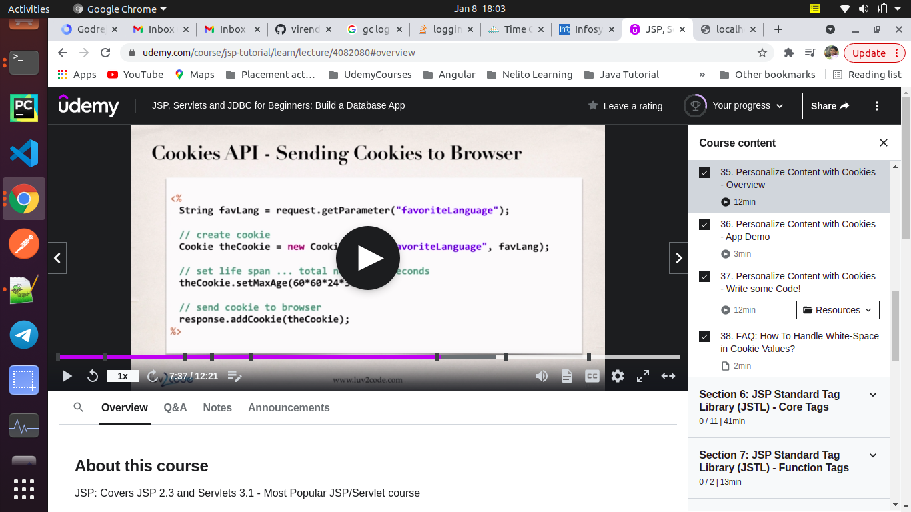
yuy
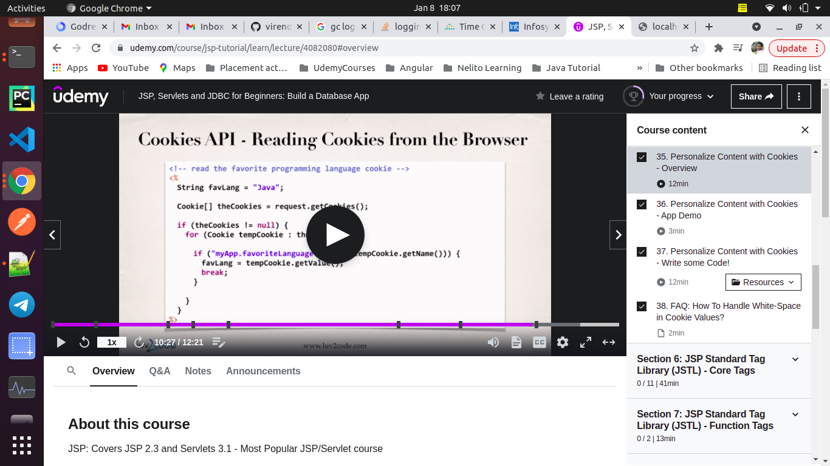
8) JSP Standard Tag Library
- Why JSTL tag ?
https://www.tutorialspoint.com/jsp/jsp_standard_tag_library.htm
Problem statement :
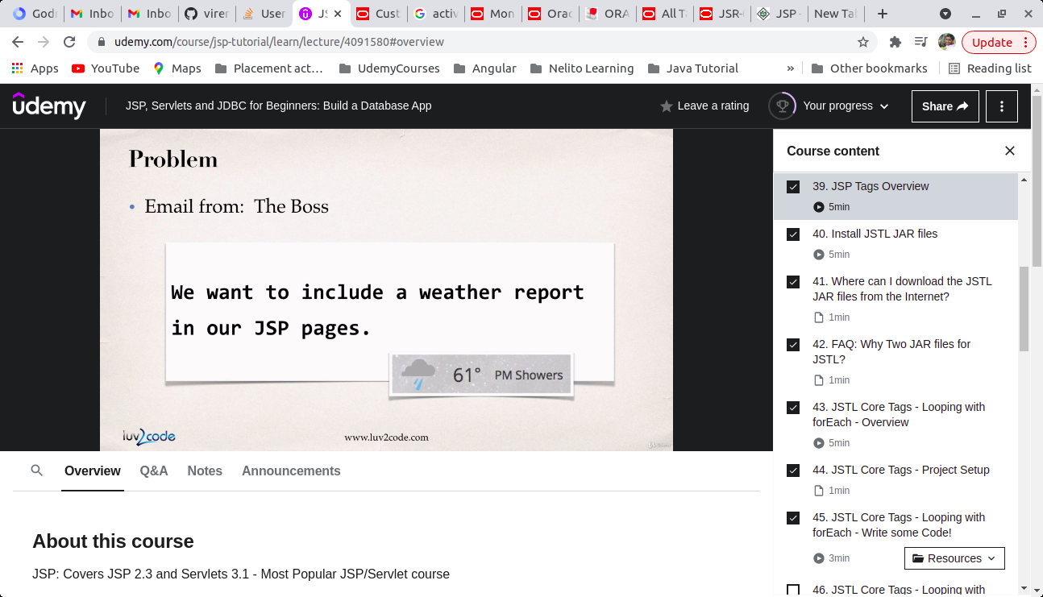

Solution 1 :
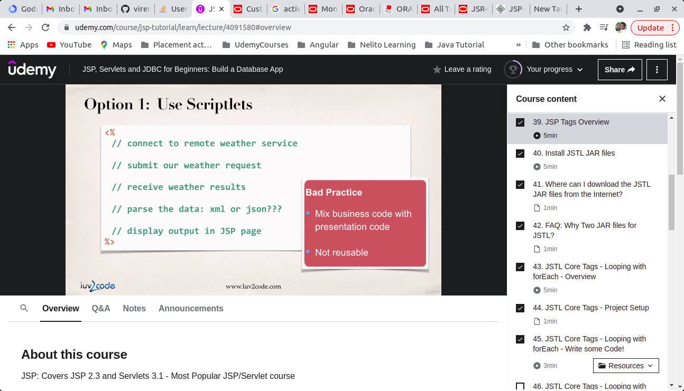

- Mix business code with presentation code & Not reuseable
Solution 2 :
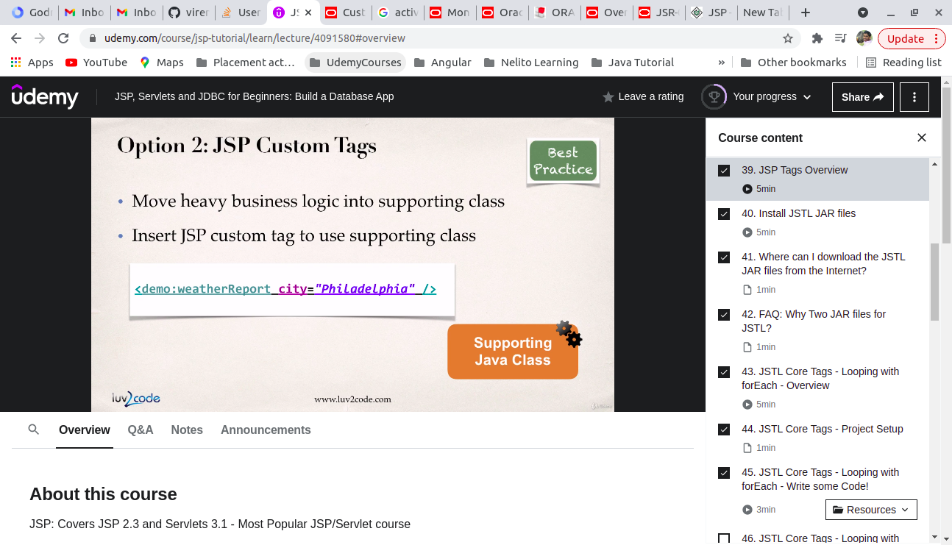
- How JSP tags are re-usable ?: https://docs.oracle.com/javaee/5/tutorial/doc/bnajb.html
- JSP Custom Tag Documentation
https://docs.oracle.com/javaee/5/tutorial/doc/bnalj.html
- JSP Standard Tag Documentation
https://docs.oracle.com/javaee/5/tutorial/doc/bnakc.html
- JSTL Website
https://javaee.github.io/jstl-api/
- Benefits of custom tag
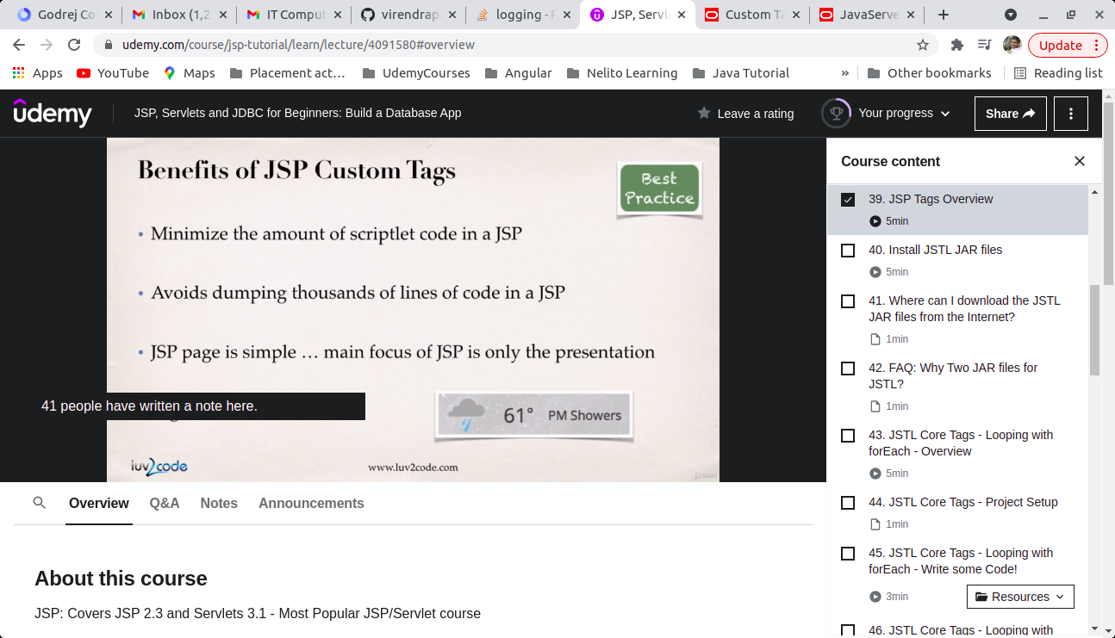
- To download JAR files
http://www.luv2code.com/download-jstl
- Dynamic Project Location
File -> Others -> Web -> Dynamic Web Projects Times New Roman
- How to add JSP file inside Web INF
Click right click on webapp -> File -> Name JSP file
- Why two JAR require ?
javax.servlet.jsp.jstl-api-1.2.1.jar:
- This contains the JSTL API interfaces and support classes. However a large number of the interfaces do not have implementation classes.
javax.servlet.jsp.jstl-1.2.1.jar :
- This contains an implementation of the JSTL API. This code implements all of the interface from the API above.
- JSTL Core Tags ( Commonly Used Core Tag )
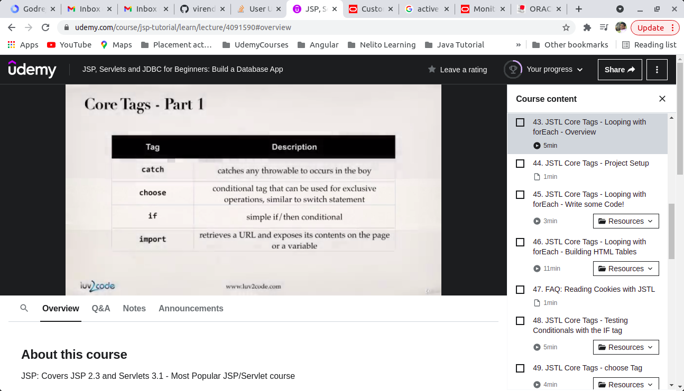
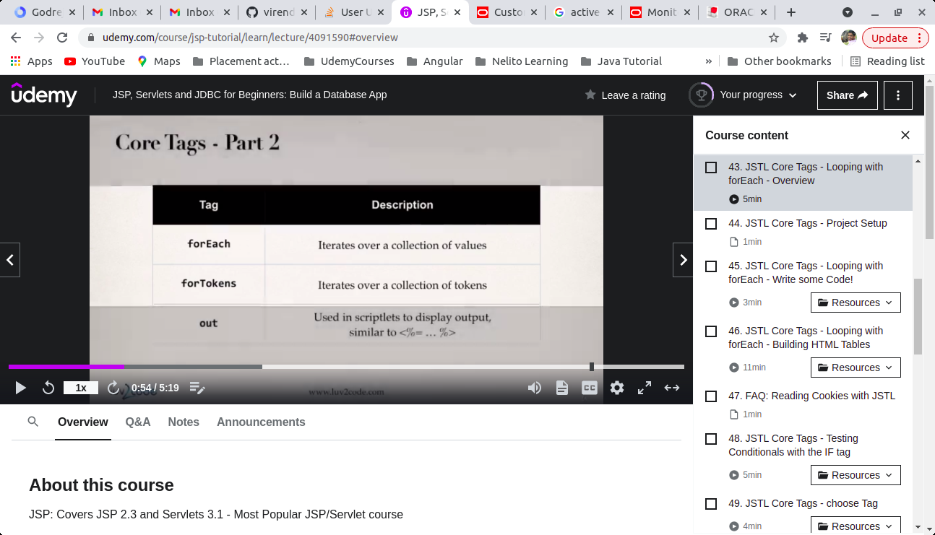
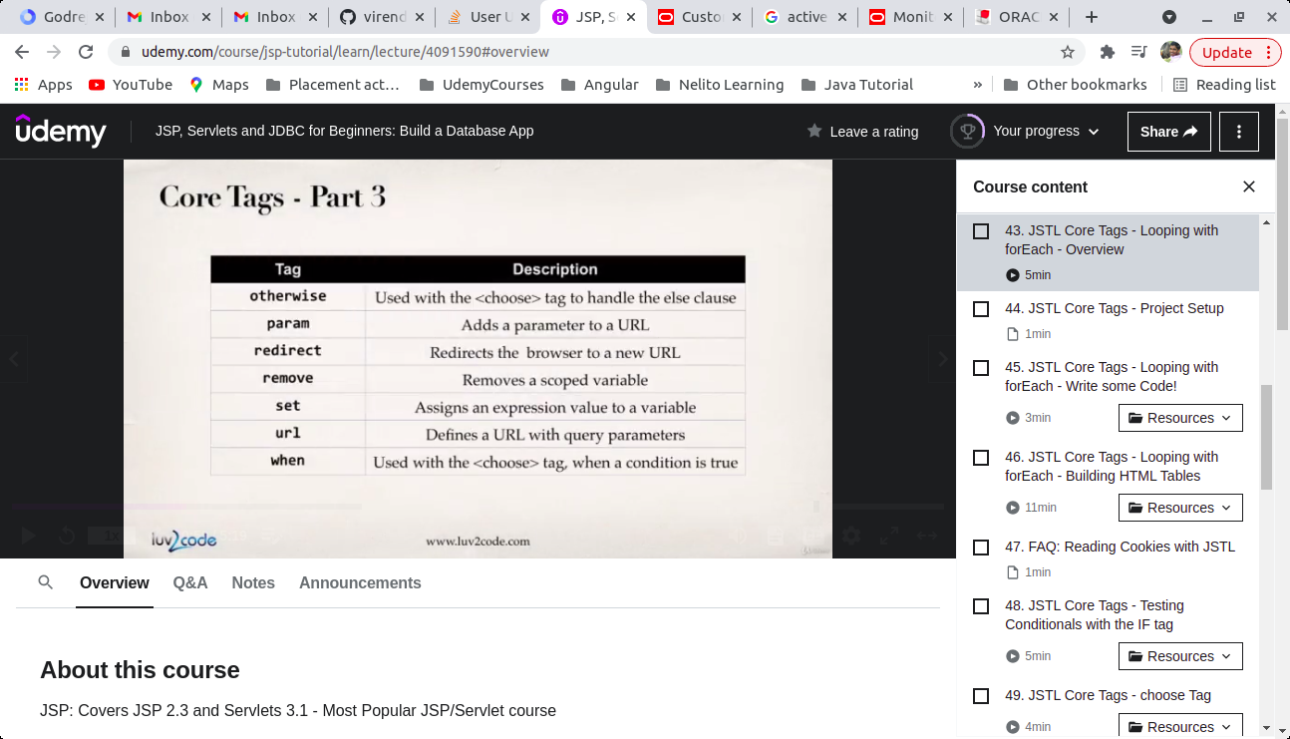
- Resources for JSTL
1. JSP Custome Tag : http://luv2code.com/tagtutorial
2. JSTL Tutorial : http://luv2code.com/jstltutorial
3. JSTL Java Doc : http://luv2code.com/jstl-javadoc
4. JSTL Spec PDF : http://luv2code.com/jstl-pdf
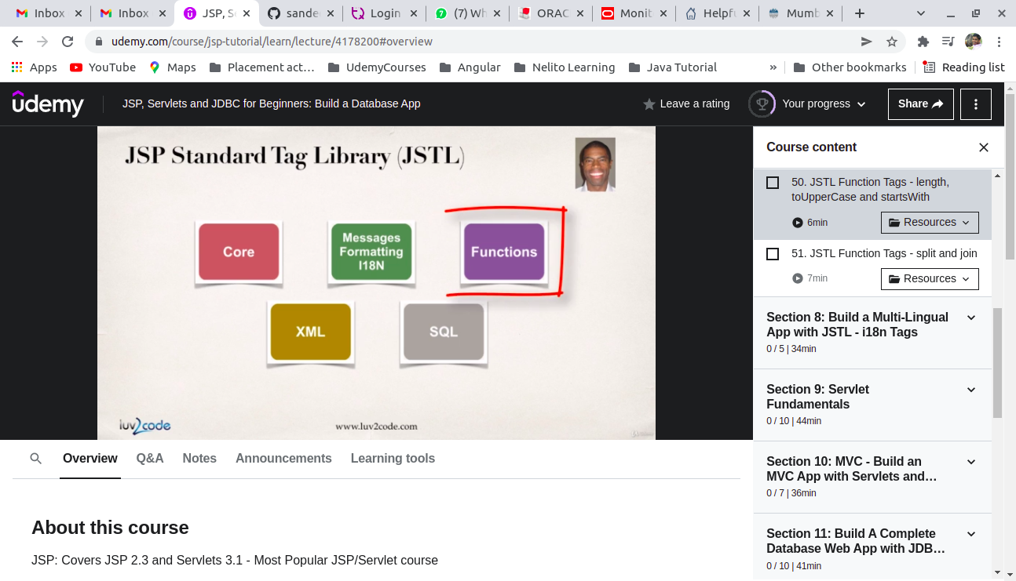

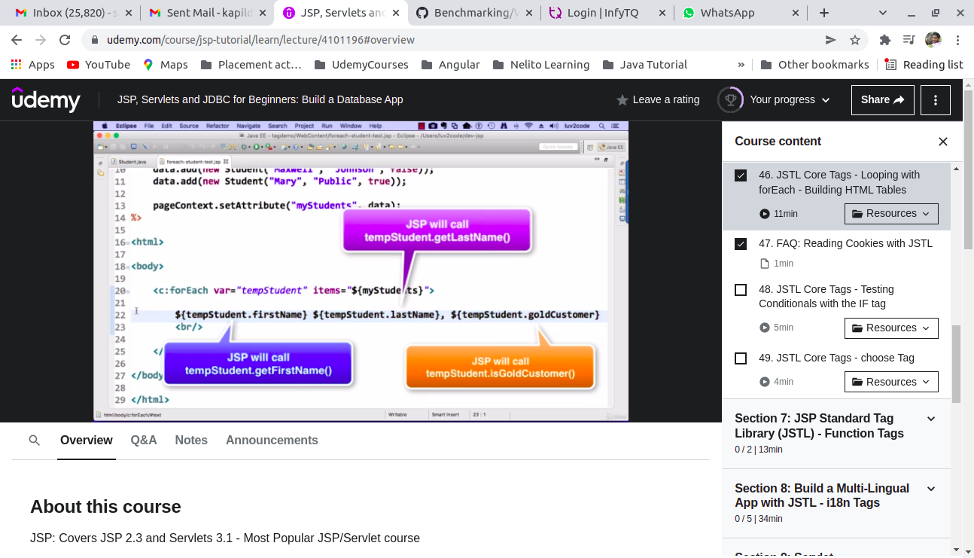
- JSTL Core Tag
a ) IF Tag
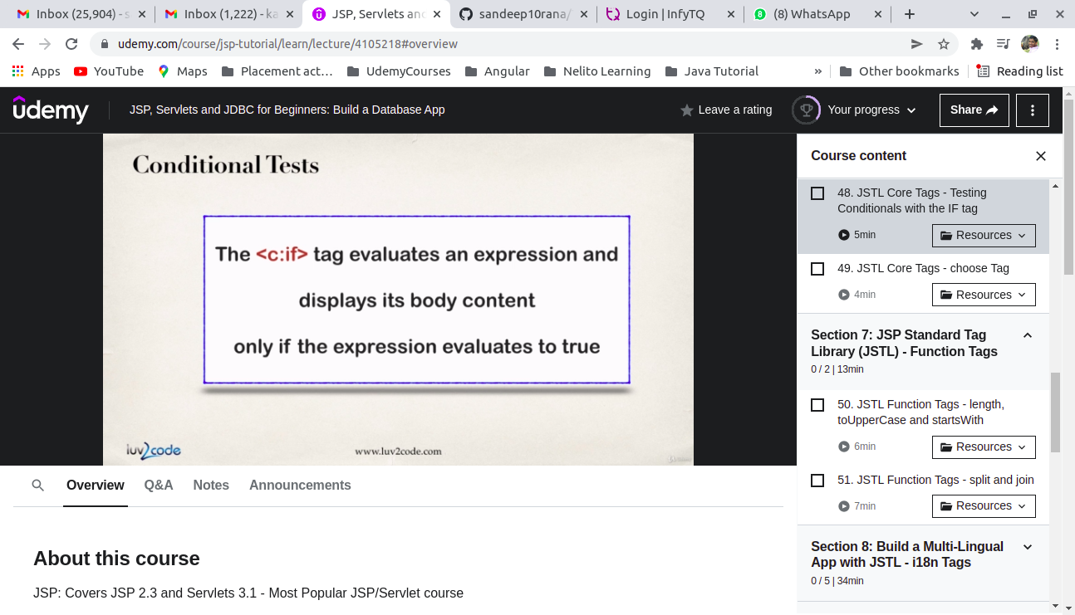
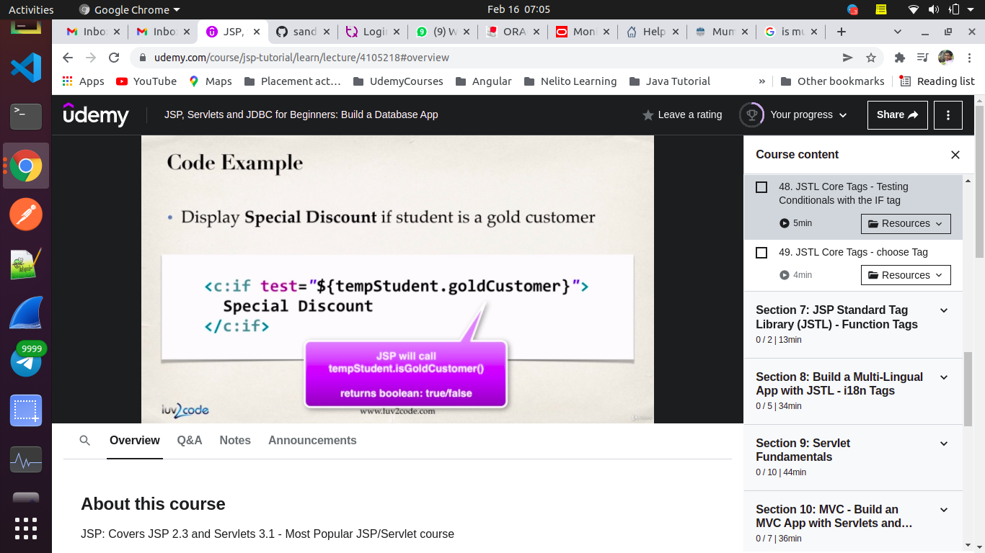
( Note : JSTL doesn’t have else tag )
b) JSTL Choose Tag
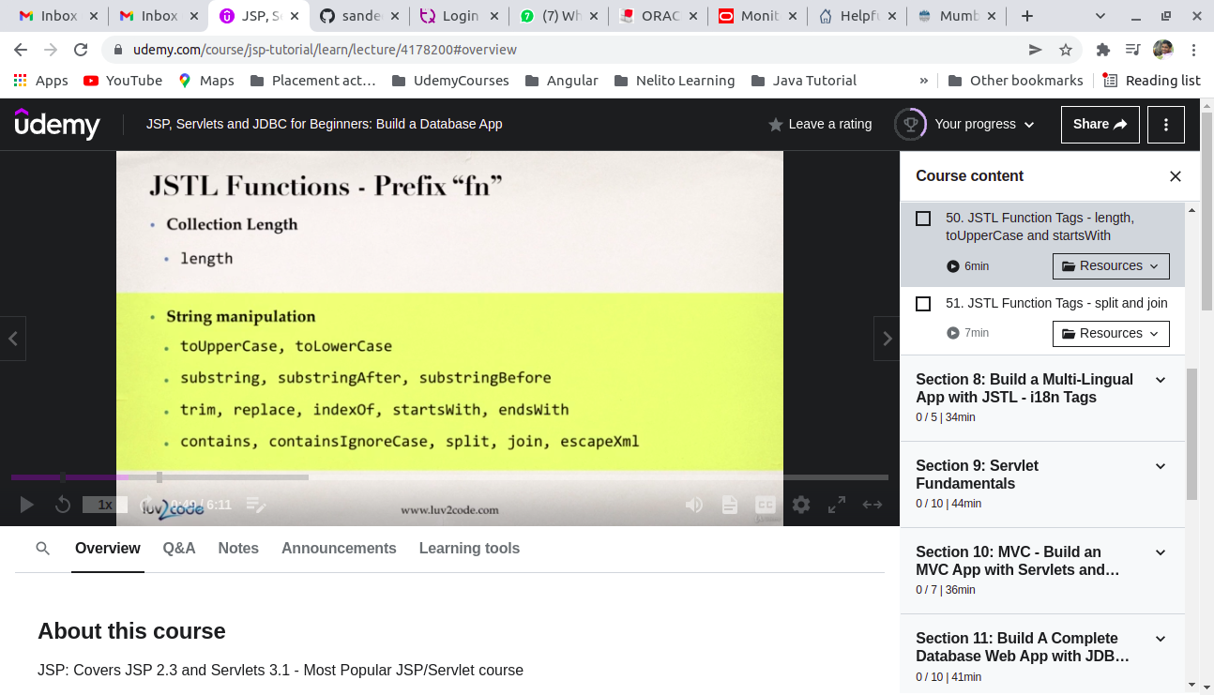
c) JSTL Function Tag
- split ()
- join ()

- JSTL Multi – Lingual App with i18n Tag
( Building a Multi lingual App without changing source code )
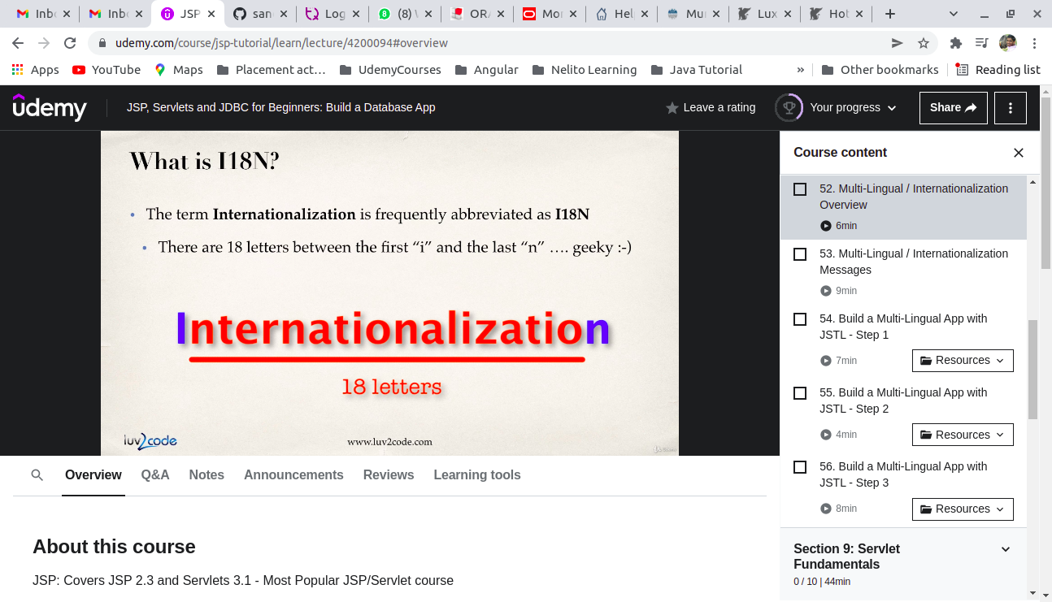
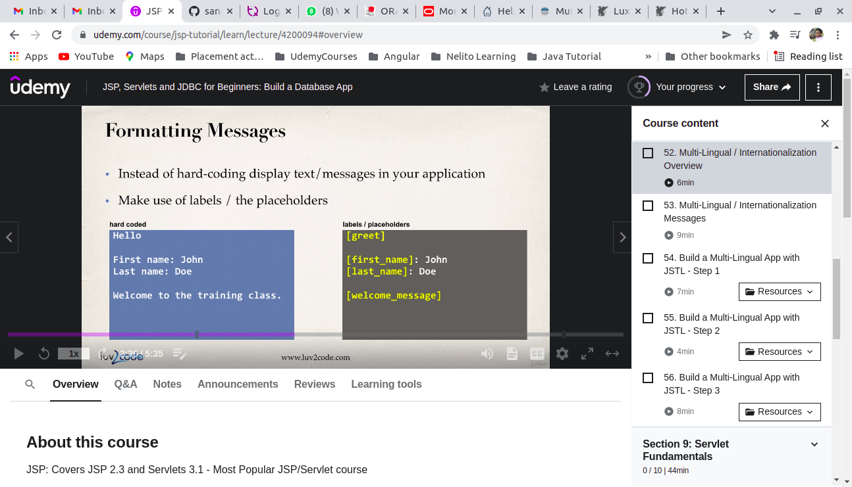
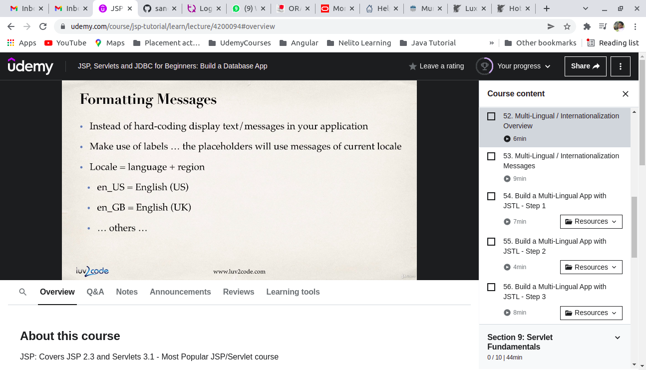
How to do that ?
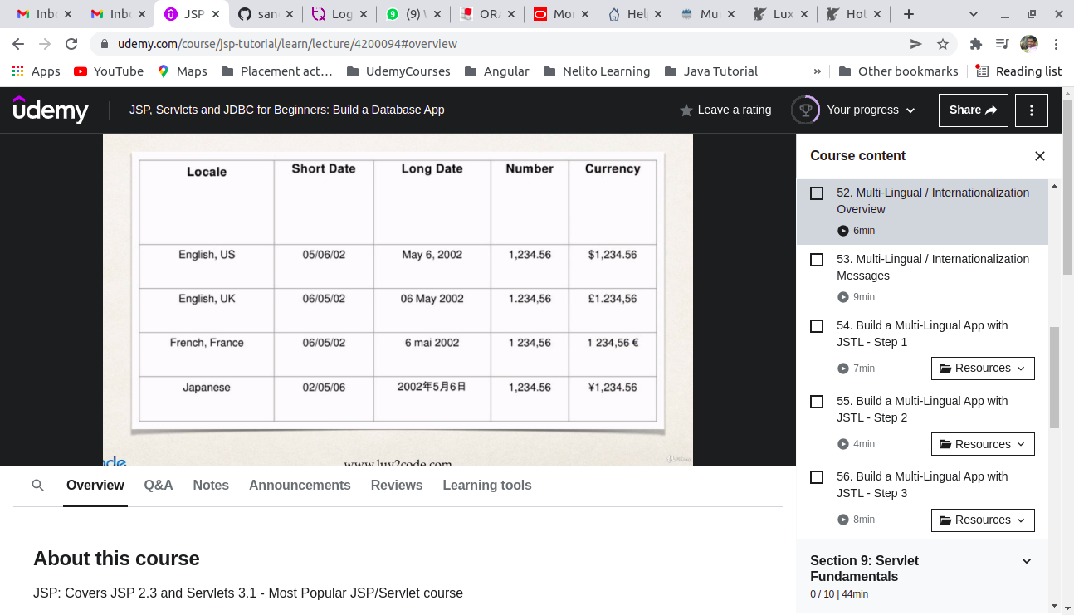
JSTL
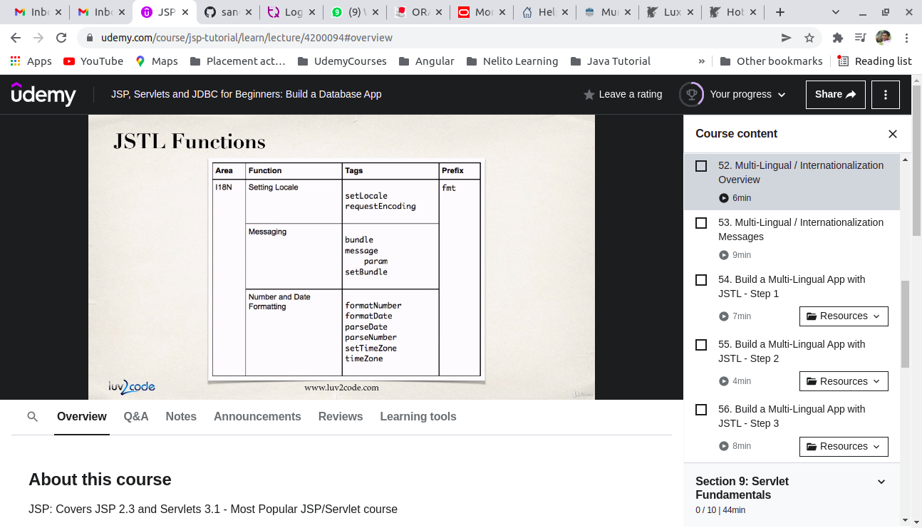
How to implement ?
Step 1 : Create resource files

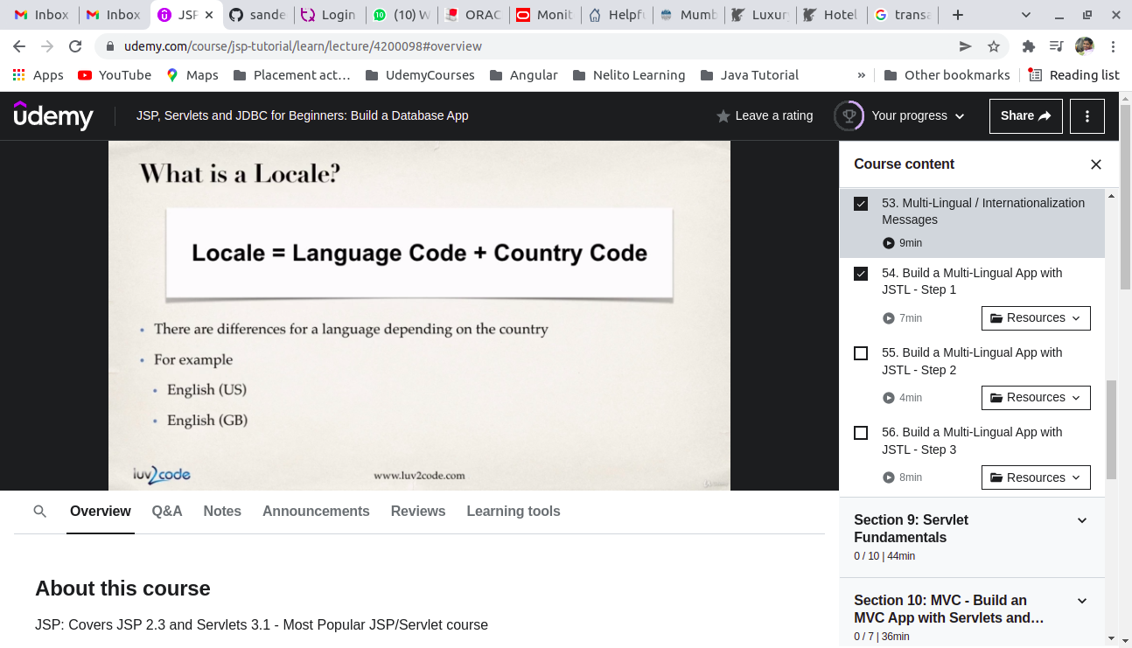
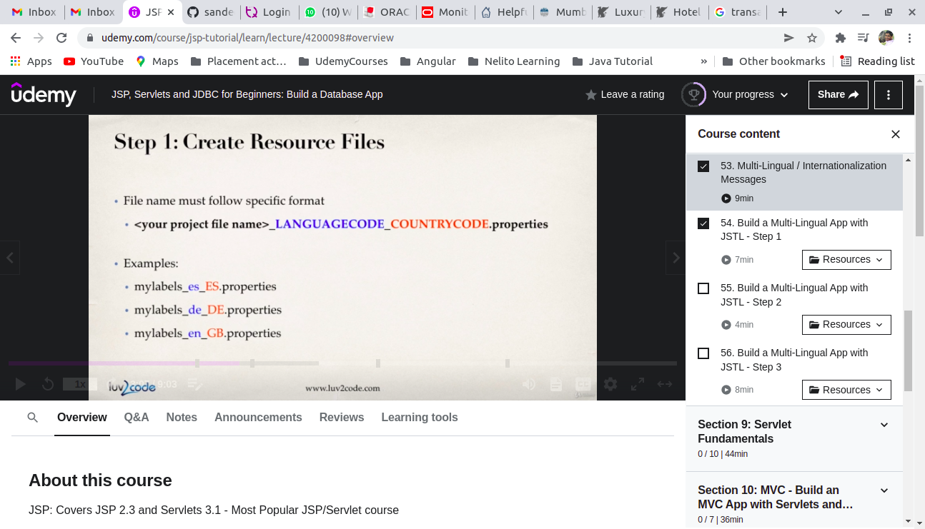
Language code :
https://en.wikipedia.org/wiki/List_of_ISO_639-1_codes
Country Code :
https://en.wikipedia.org/wiki/List_of_ISO_3166_country_codes
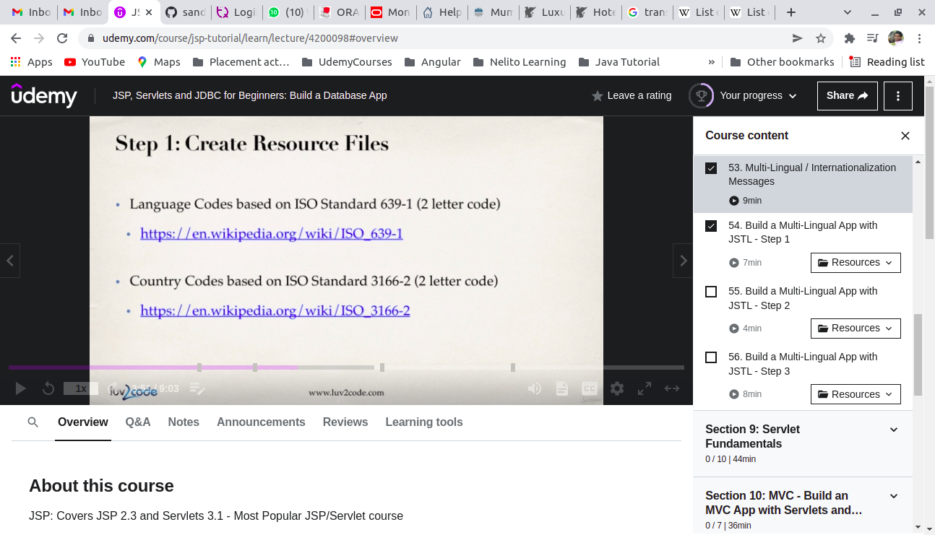
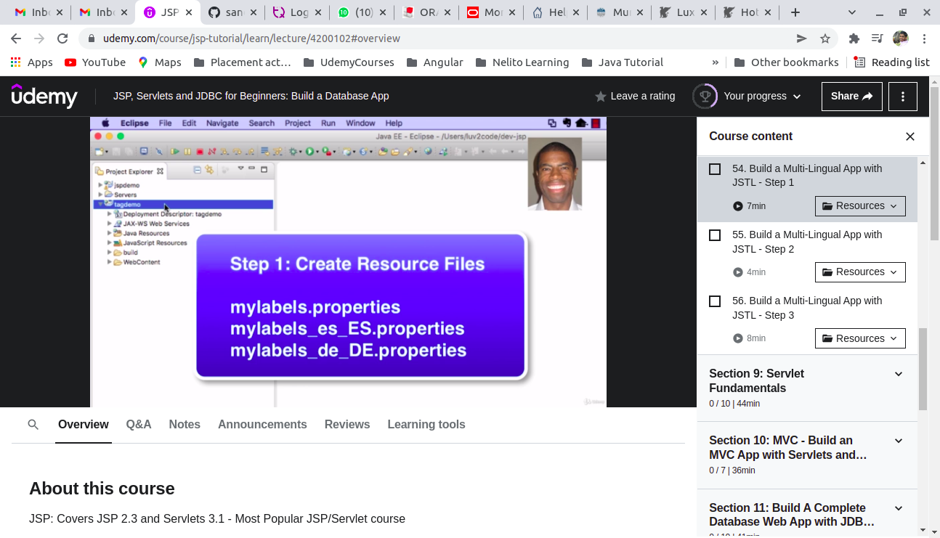
Step 2 : Creating JSP page with labels
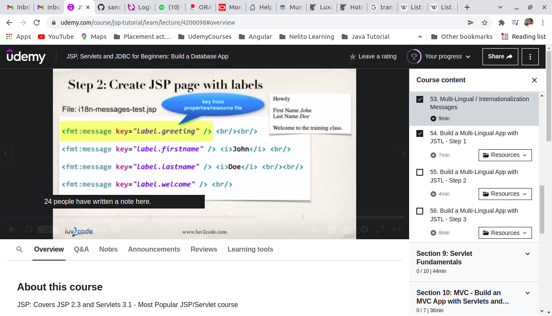
Step 3 : Update JSP page to change locale based on user selection
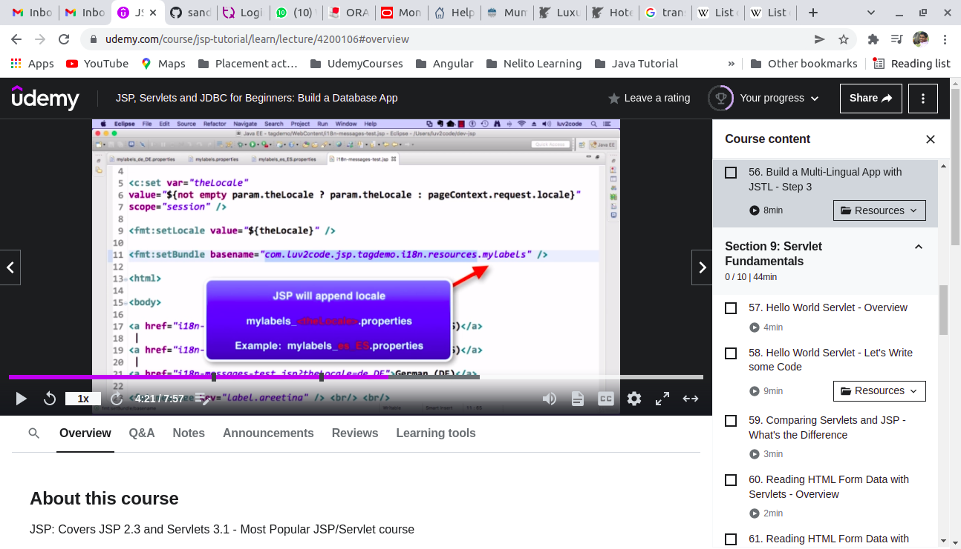
8) JSP Servlet
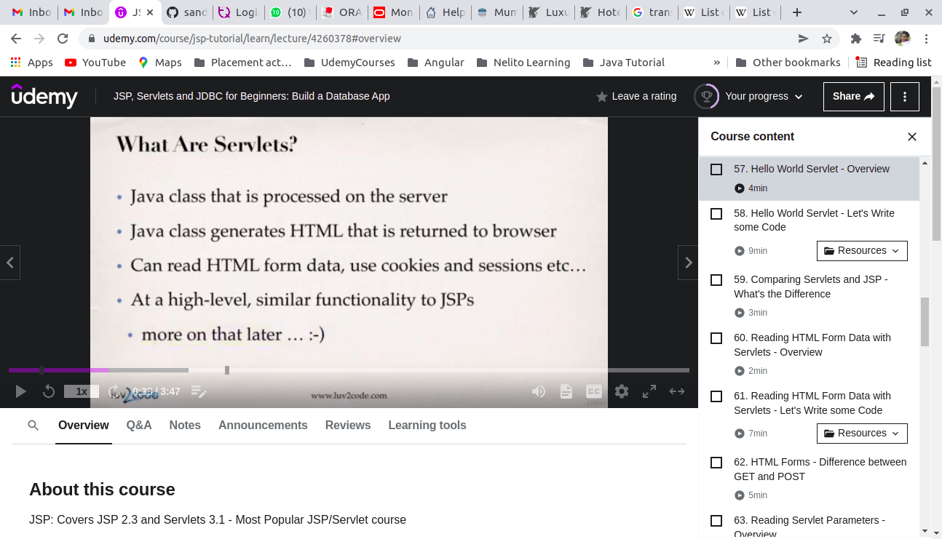
1.
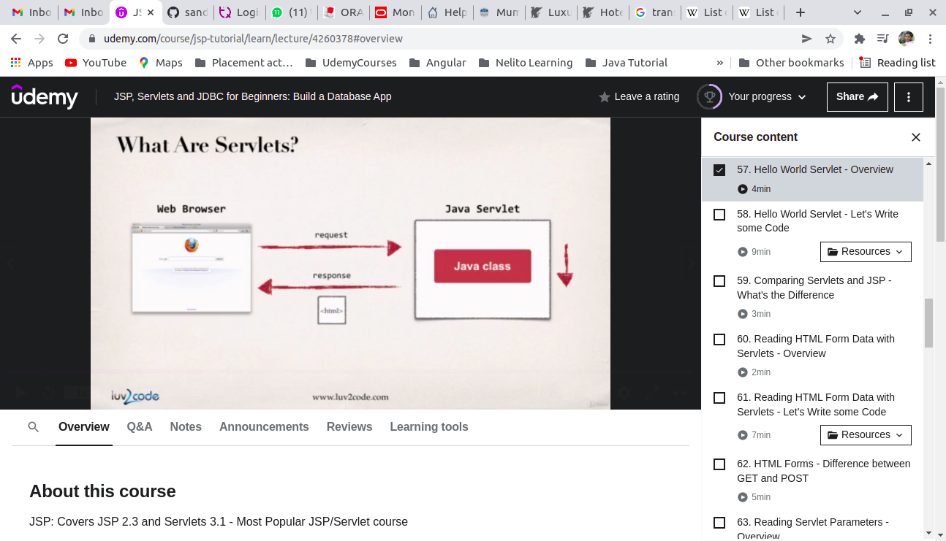
2.
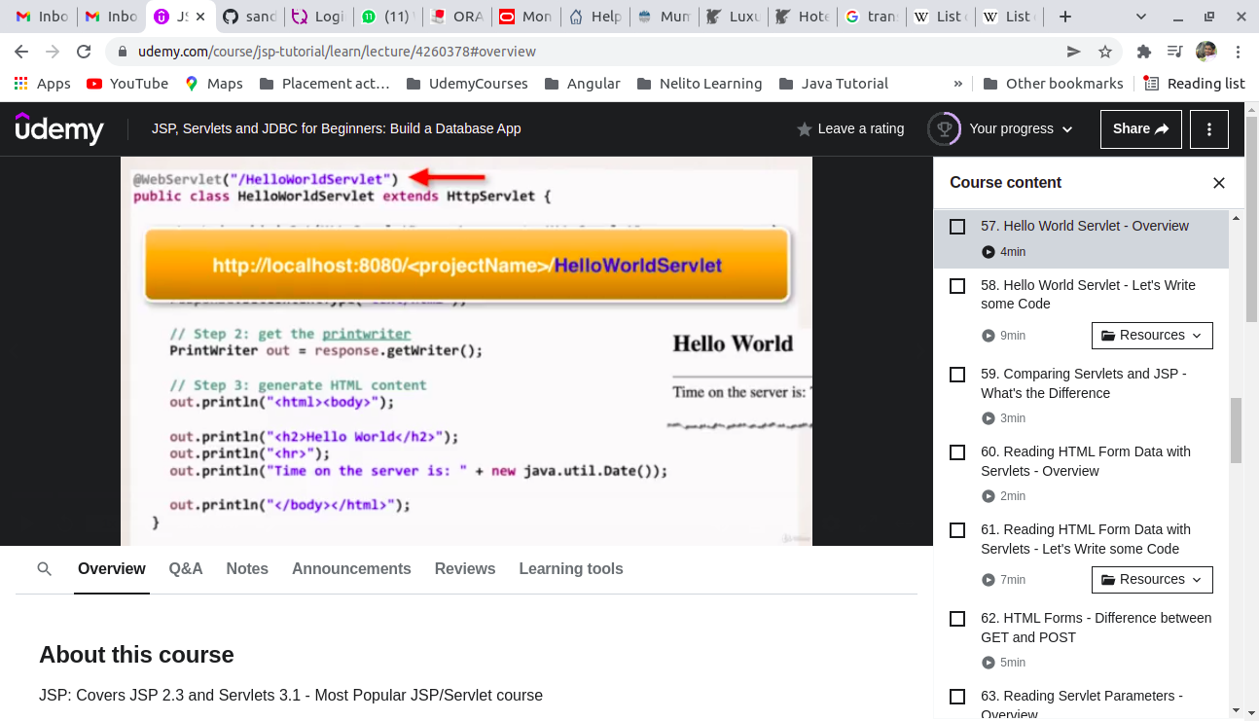
3.
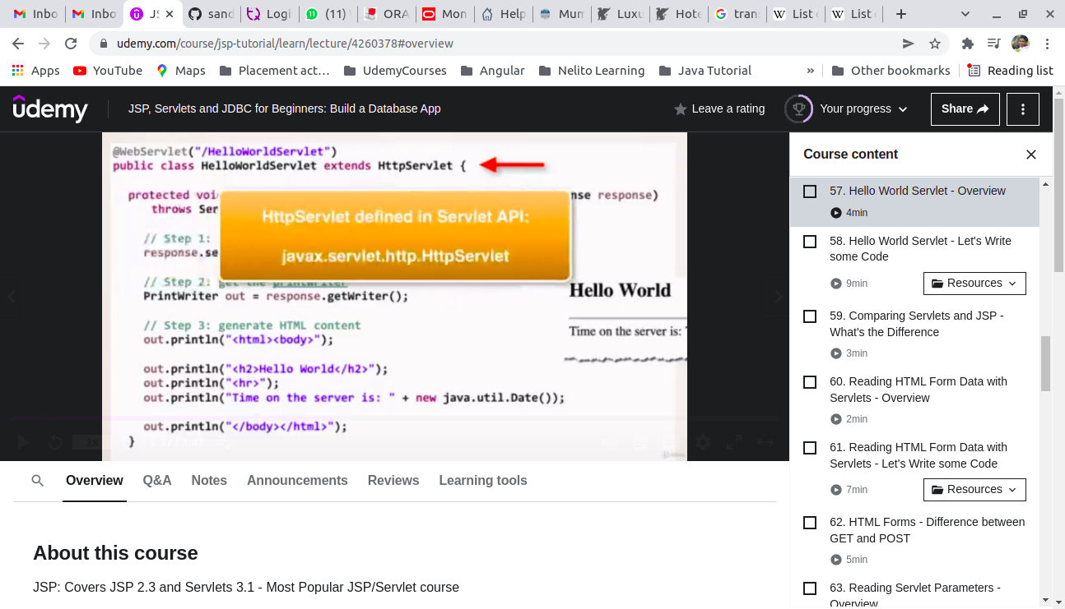
4. Difference between JSP and servlet
Reference : https://www.geeksforgeeks.org/difference-between-servlet-and-jsp/
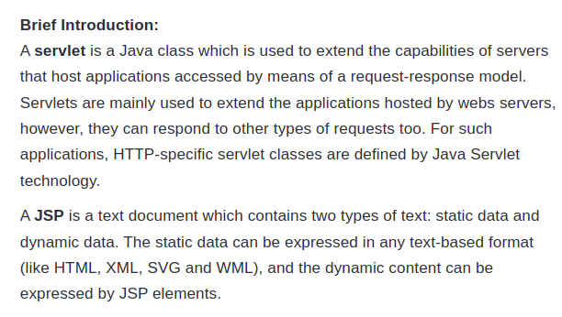
Servlet Lifecycle : https://www.geeksforgeeks.org/life-cycle-of-a-servlet/
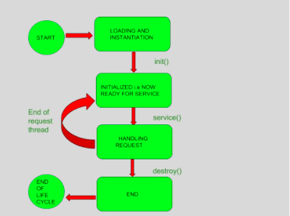

JSP Lifecycle Doc : https://www.geeksforgeeks.org/life-cycle-of-jsp/
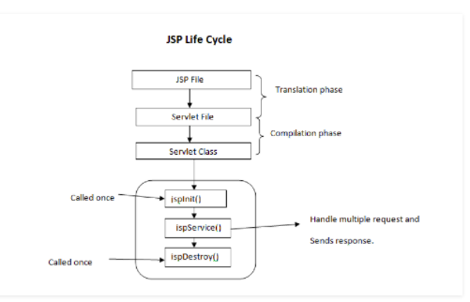

JSP Life cycle
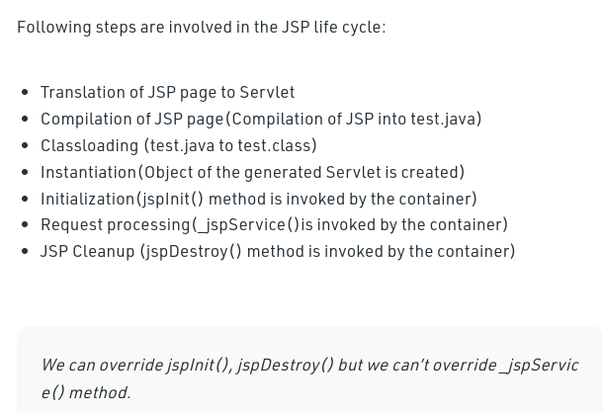

Exact difference
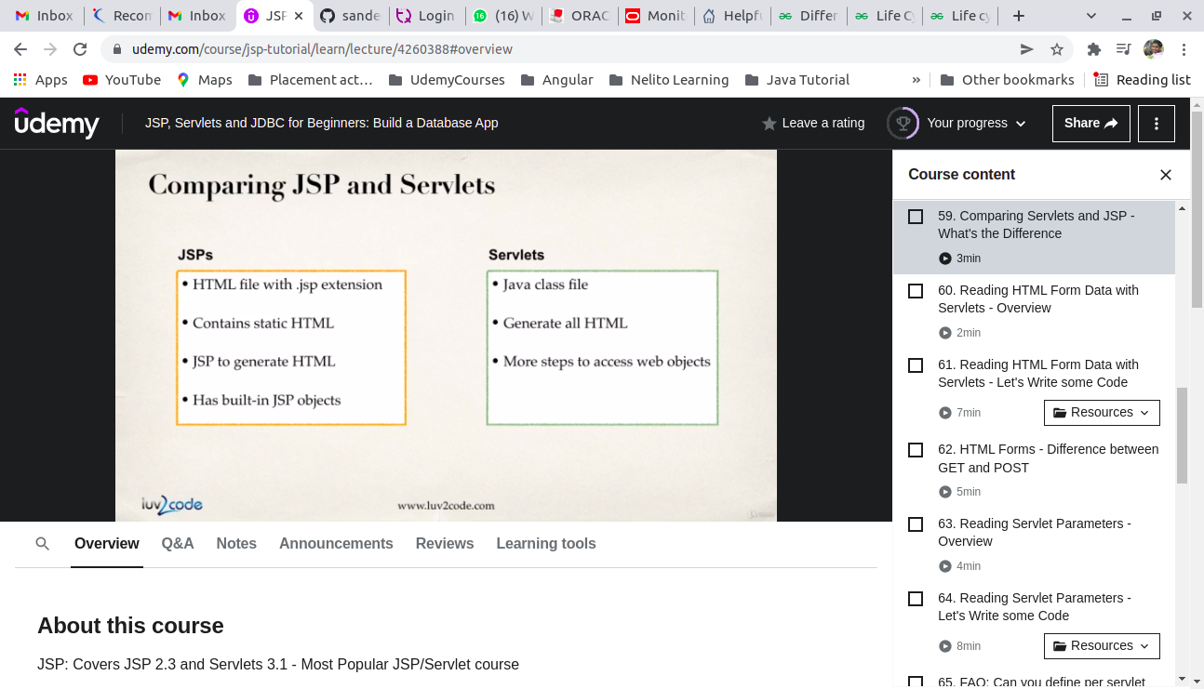
History
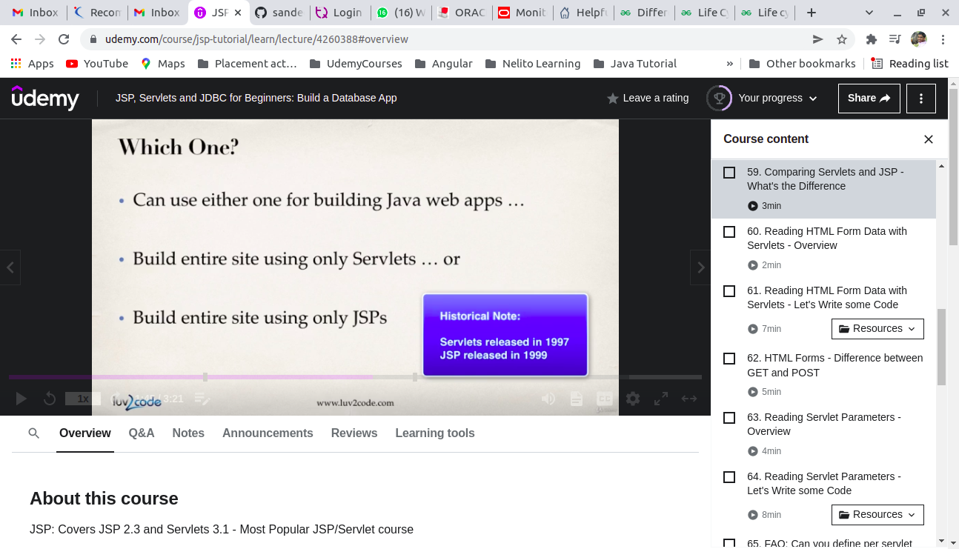
Best practise
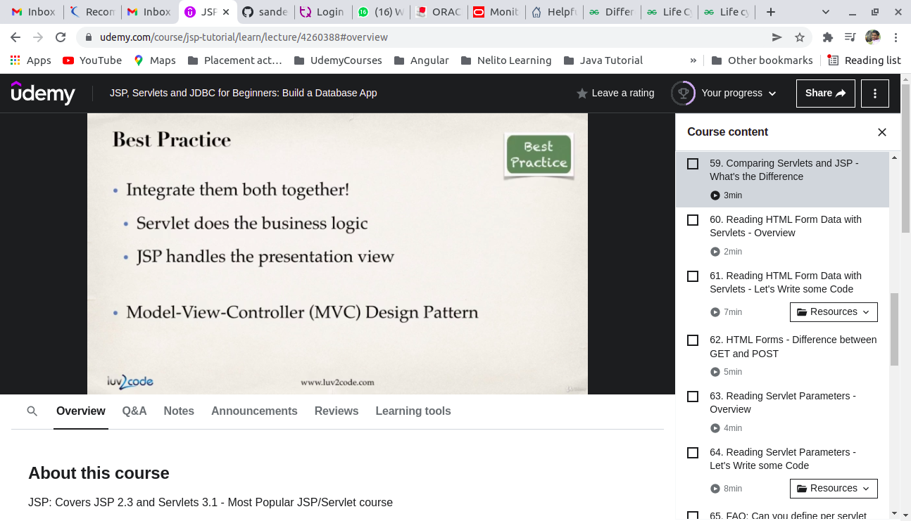
Reading form data with servlet ( GET method )

To create new servlet in Eclipse
Right click on package -> New -> File -> Search Servlet
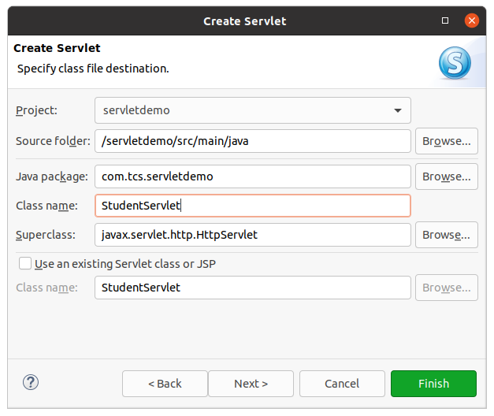
Reading form data with servlet ( POST method )
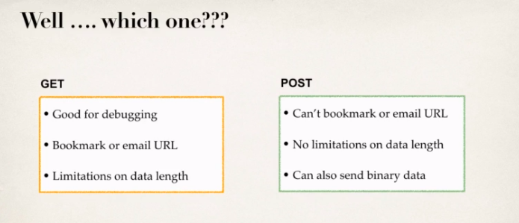
Reading servlet parameters
( Parameter like web.xml , mfi.properties , etc )
How can I create web.xml in Eclipse?
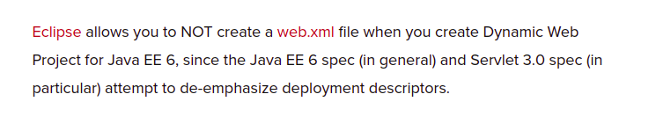
Solution :
Right click on Dynamic web project -> Java EE Tools -> Generate Deployment Scriptors Stub
It will generate web.xml immediately.
9 ) MVC ( Model View Controller ) Design Pattern
Why Design Pattern require and types of design pattern ?
https://www.geeksforgeeks.org/design-patterns-set-1-introduction/?ref=lbp
Documentation :
https://www.geeksforgeeks.org/mvc-design-pattern/
https://www.c-sharpcorner.com/article/what-is-mvc-and-why-we-use-mvc/

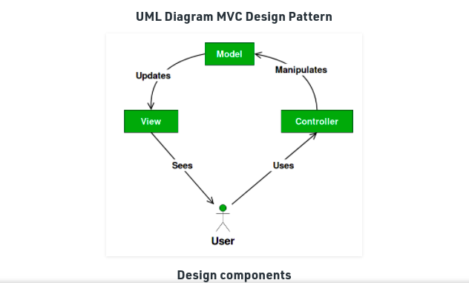
Alternatives of MVC :
https://blog.ircmaxell.com/2014/11/alternatives-to-mvc.html
Flow Diagram :
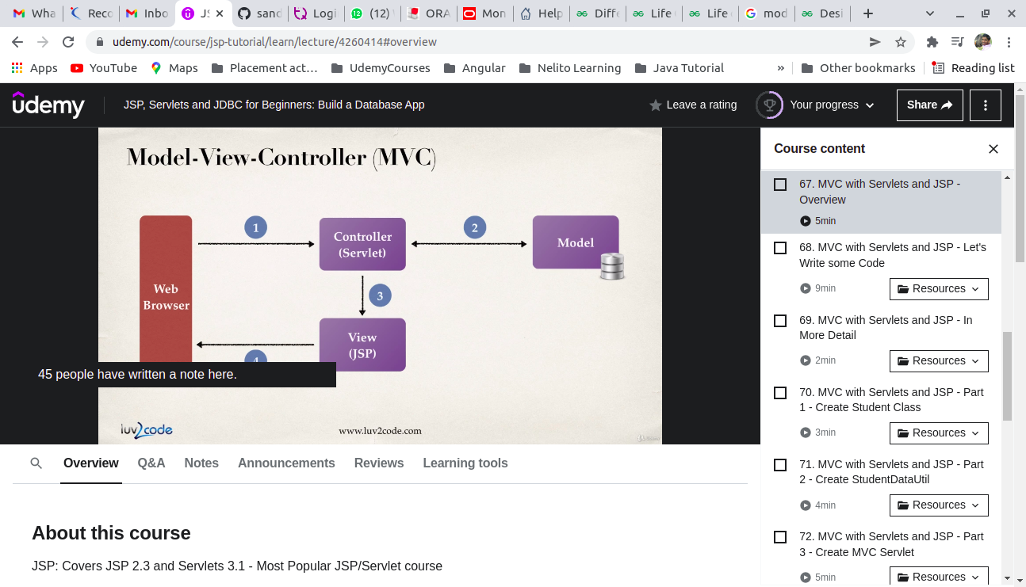
For resume point of view :
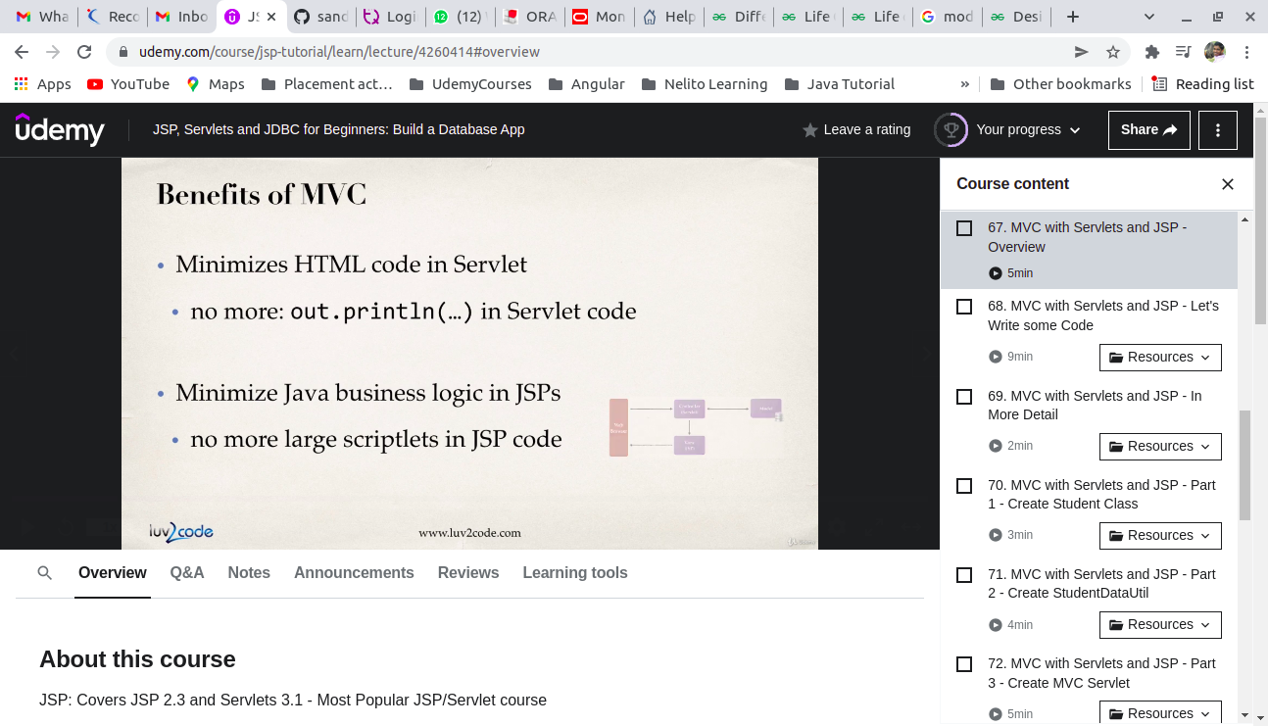
How servlet can call JSP ?
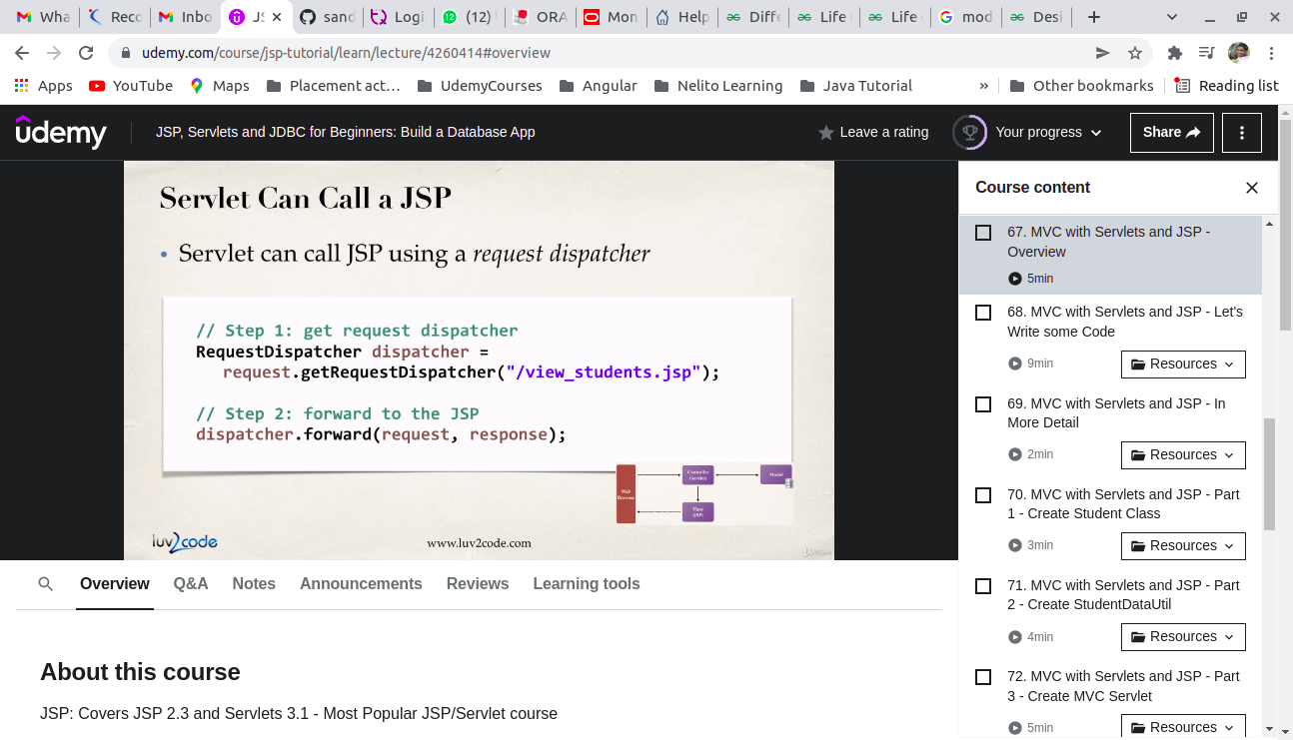
JSP to access the data ?
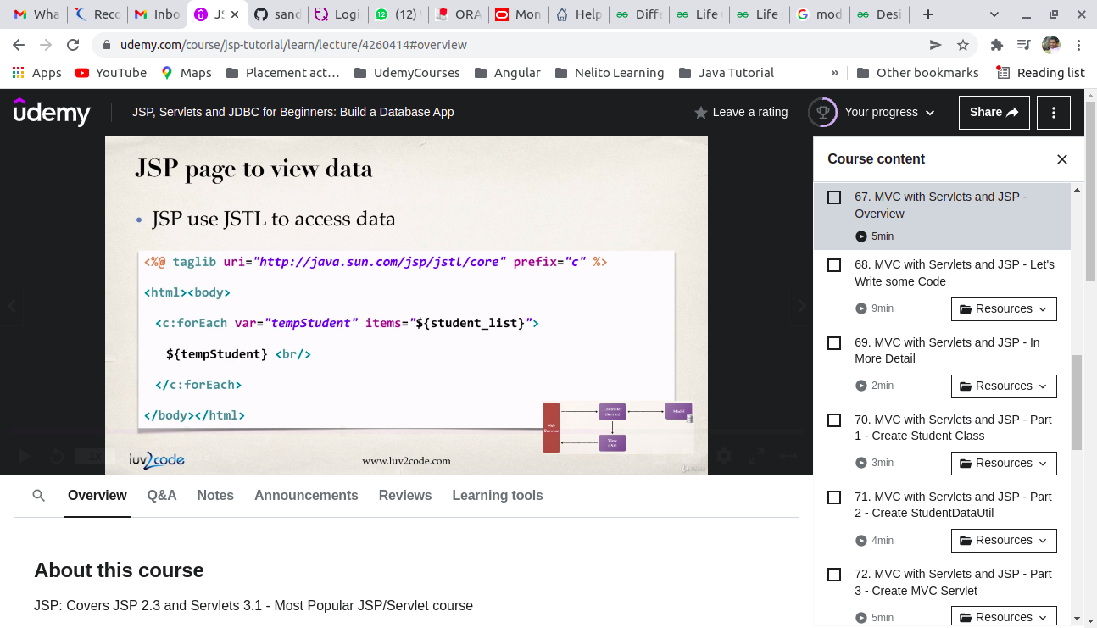
How to implement MVC with Servlet and JSP ? ( Steps with Model ) :
1 . Add JSTL support to servlet demo project
2 . Create Controller servlet
3 . Create view JSP
How to implement MVC with Servlet and JSP ? ( Advanced Steps with Model ) :

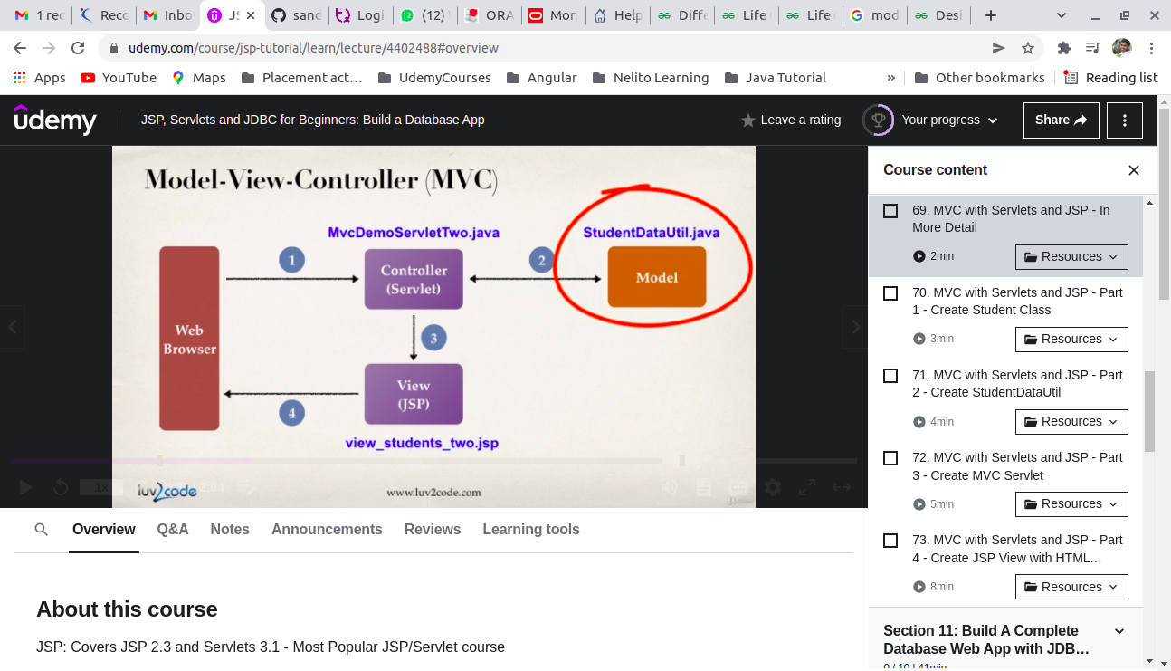
Steps :
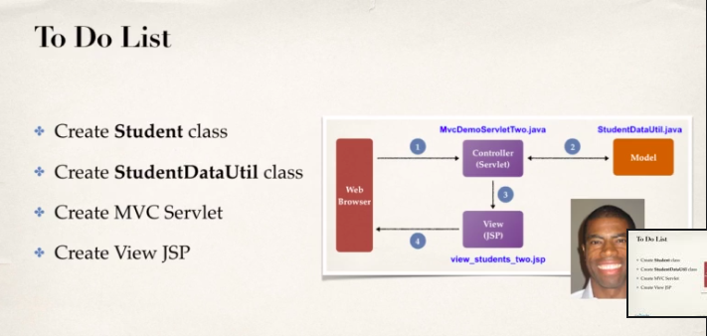
StudentDataUtils :
https://www.javatpoint.com/java-list
https://www.geeksforgeeks.org/list-interface-java-examples/
9) Create Database application using JSP and Servlet - Part 1
Roadmap :
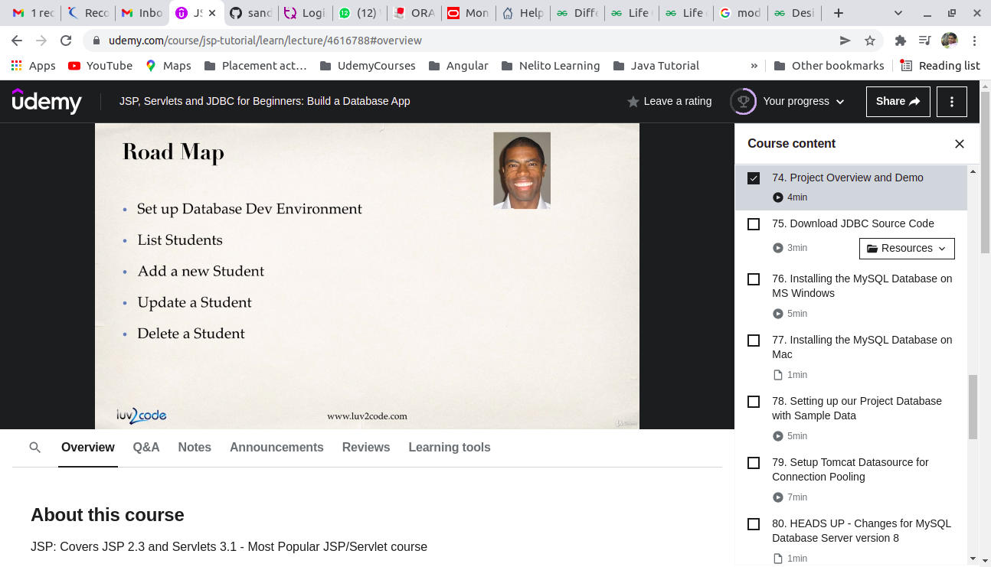
How to install mysql on ubuntu ( Steps )
- Update the system package repository to ensure you are installing the latest MySQL release.
sudo apt update
sudo apt upgrade
- After successfully updating the package repository, install MySQL Server by running the following command:
sudo apt install mysql-server
- Check if MySQL was successfully installed by running:
mysql --version
Reference: https://phoenixnap.com/kb/install-mysql-ubuntu-20-04

How to launch mysql on ubuntu
Reference : https://www.tutorialrepublic.com/faq/how-to-start-stop-mysql-server-on-ubuntu.php
sudo service mysql status

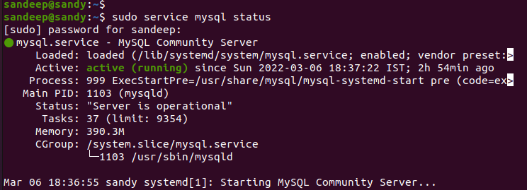
fsd
Reference :
https://stackoverflow.com/questions/16556497/mysql-how-to-reset-or-change-the-mysql-root-password
https://stackoverflow.com/questions/1712806/how-to-get-all-privileges-back-to-the-root-user-in-mysql
To remove mysql package completely ( Steps )
1. Stop the mysql -> To remove packages
services sudo apt-get remove --purge mysql-server mysql-common
2. To remove configuration directory and data directory
mv /etc/mysql/mysql /etc/mysql/mysql_bkp_08032022
mv /var/lib/mysql /var/lib//mysql/mysql_bkp_08032022
3.To remove unused dependency
sudo apt-get autoremove
4. To remove all local repository
sudo apt-get autoclean
5. To remove mysql related local files
sudo apt-get purge mysql*
To install mysql on Ubuntu ( Steps )
1. sudo apt update
2. sudo apt upgrade
3. sudo apt install mysql-server
4. sudo apt install mysql-server
5. sudo mysql_secure_installation

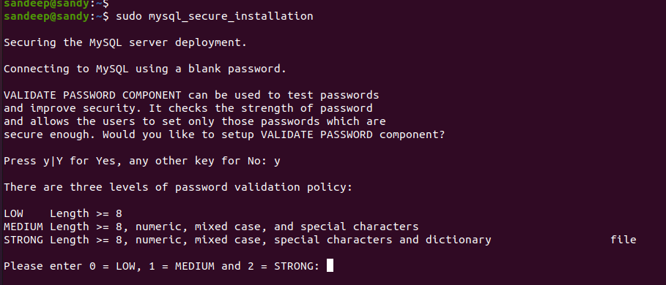
Pwd : sandeep
Settings to be remember :
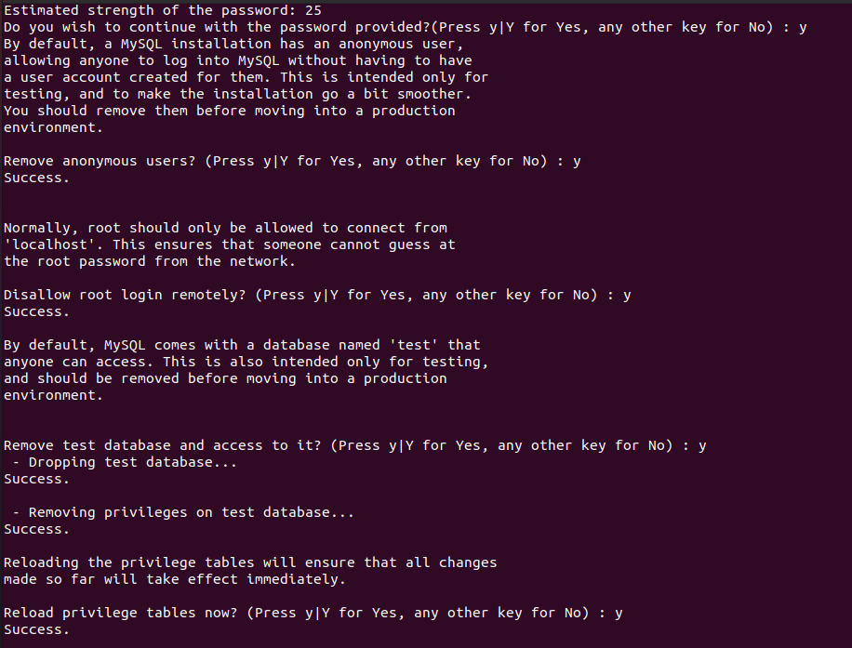
6. sudo mysql -u root
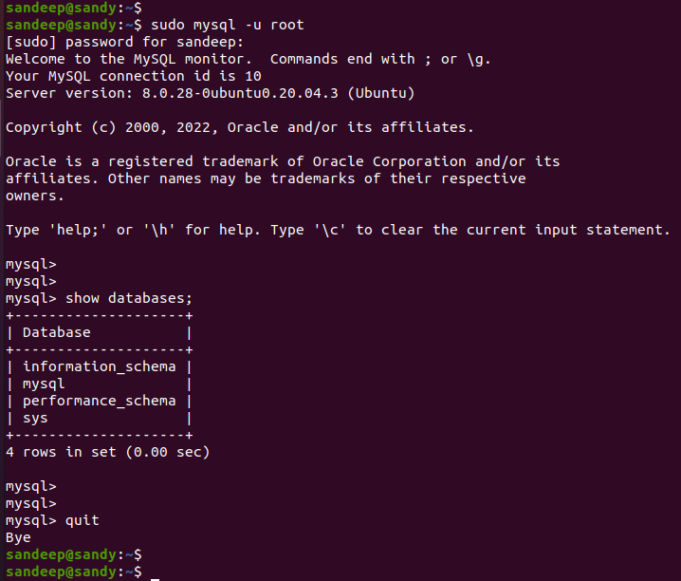
a) Setting up our Project Database with sample Data
CREATE USER 'webstudent'@'localhost' IDENTIFIED BY 'Sbi@123' ;
GRANT ALL PRIVILEDGES ON * . * TO 'webstudent'@'localhost';
To resolve password policy issue :
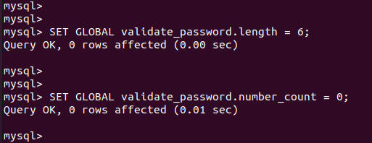

Before updation :
mysql> SHOW VARIABLES LIKE 'validate_password%';
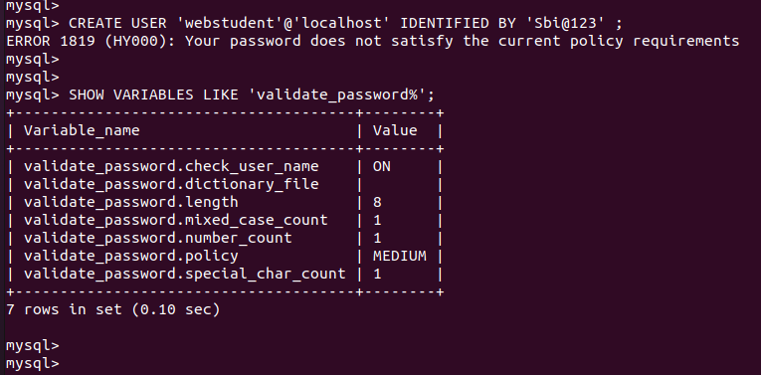
After updation:
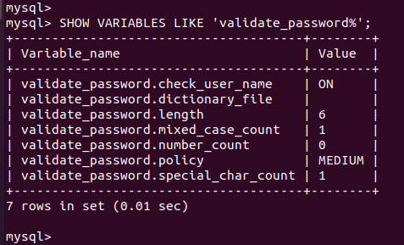
SQL Source Code :
/home/sandeep/Documents/JSP SERVLET & JDBC/jsp-servlet-jdbc-source-code-v3/jsp-servlet-jdbc-source-code-v3/sql-scripts
Output of the module :
java.sql.SQLException: Cannot create PoolableConnectionFactory (Public Key Retrieval is not allowed) – Need to work on
--------------------------------------------------------------------------------

- MYSQL troubleshooting documentation :
https://dev.mysql.com/doc/connector-j/8.0/en/connector-j-reference-configuration-properties.html

- For JDBC Pool for high concurrency ( Important )

https://my.oschina.net/shipley/blog/519449

- For Tunning Apache Tomcat for high performance ( Important )

https://www.eginnovations.com/blog/tomcat-performance-tuning/

https://medium.com/@pawilon/tuning-your-linux-kernel-and-haproxy-instance-for-high-loads-1a2105ea553e

Order of troubleshooting

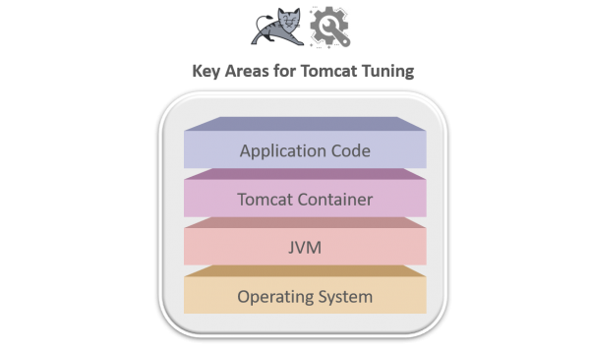

a ) OS level

-> OS parameters

https://medium.com/@pawilon/tuning-your-linux-kernel-and-haproxy-instance-for-high-loads-1a2105ea553e

-> To improve network performance

https://docs.microsoft.com/en-us/biztalk/technical-guides/settings-that-can-be-modified-to-improve-network-performance

b ) JVM

-> How fast is your java ?

https://www.optaplanner.org/blog/2019/01/17/HowMuchFasterIsJava11.html

-> XX Flag for different JRE version

https://dzone.com/articles/permgen-and-metaspace

-> What to monitor ?

https://www.eginnovations.com/tomcat-monitoring

-> What is Java thread ?

https://www.eginnovations.com/blog/java-threads/ --- Nice Article

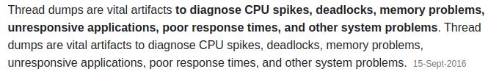
Different types of thread

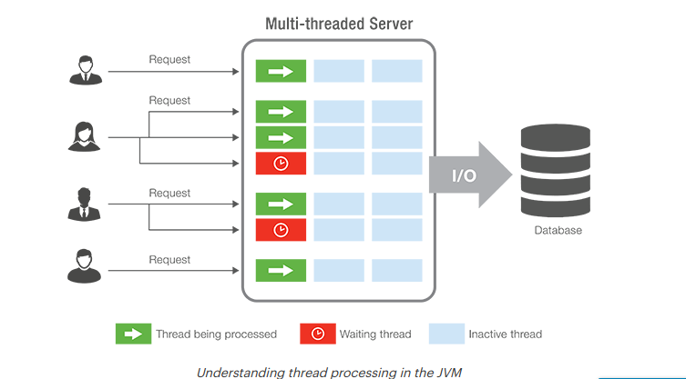
-> How to deal with thread block and deadlocks issue ( steps to troubleshoot )

https://www.eginnovations.com/blog/troubleshooting-java-application-deadlocks-diagnosing-application-hang-situations/

c ) Tomcat container

-> Connector comparison

https://tomcat.apache.org/tomcat-9.0-doc/config/http.html#Connector_Comparison

-> Configuration of SSL certificate

https://www.eginnovations.com/blog/troubleshooting-web-applications-ssl-issues/

-> GZIP Algorithm

http://www.infinitepartitions.com/art001.html

d ) To identify code level issue

-> Distributed transaction tracing techniques

https://www.eginnovations.com/blog/distributed-transaction-tracing/

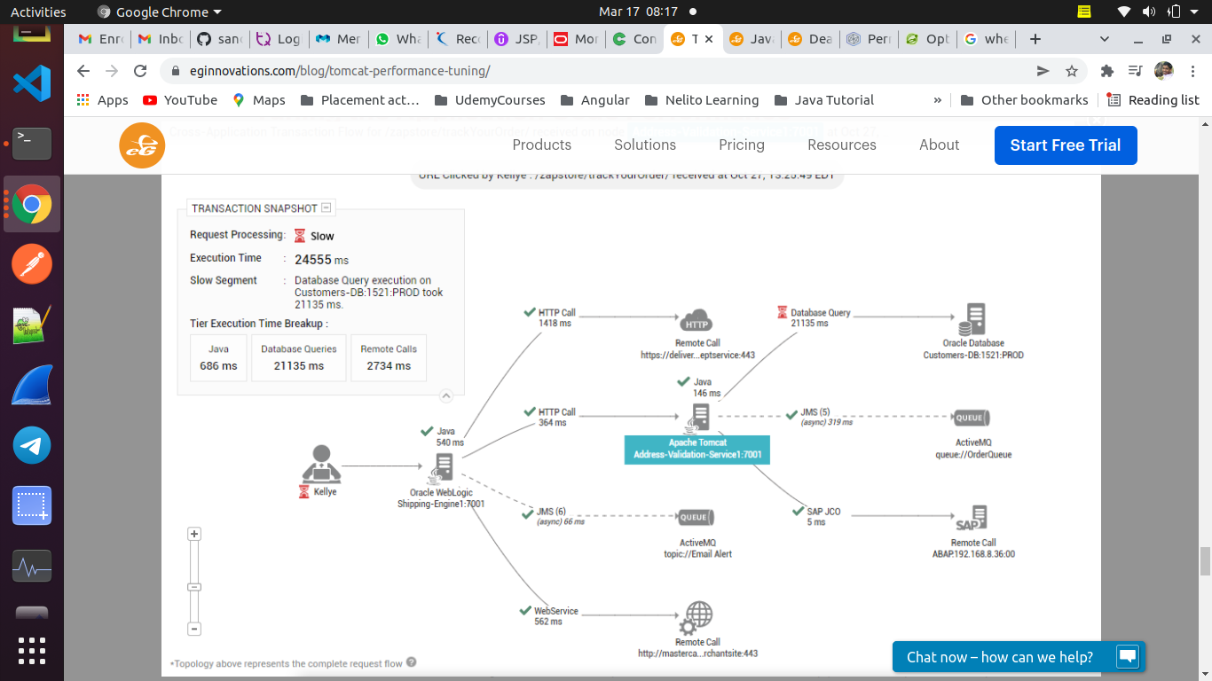
-> Instrumentation API

https://docs.oracle.com/javase/7/docs/api/java/lang/instrument/Instrumentation.html

-> Java transaction monitoring

https://www.eginnovations.com/java-transaction-monitoring

- For optimal no of connections in connection pool

https://stackoverflow.com/questions/1208077/optimal-number-of-connections-in-connection-pool

MVC Application Architechture

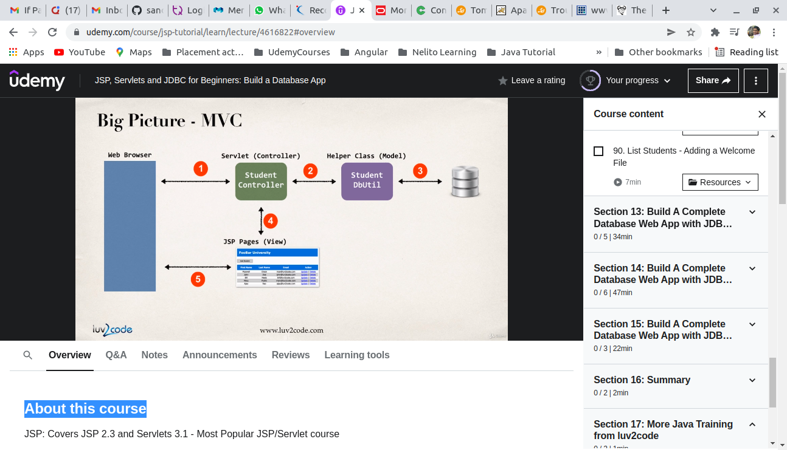
DB Utility
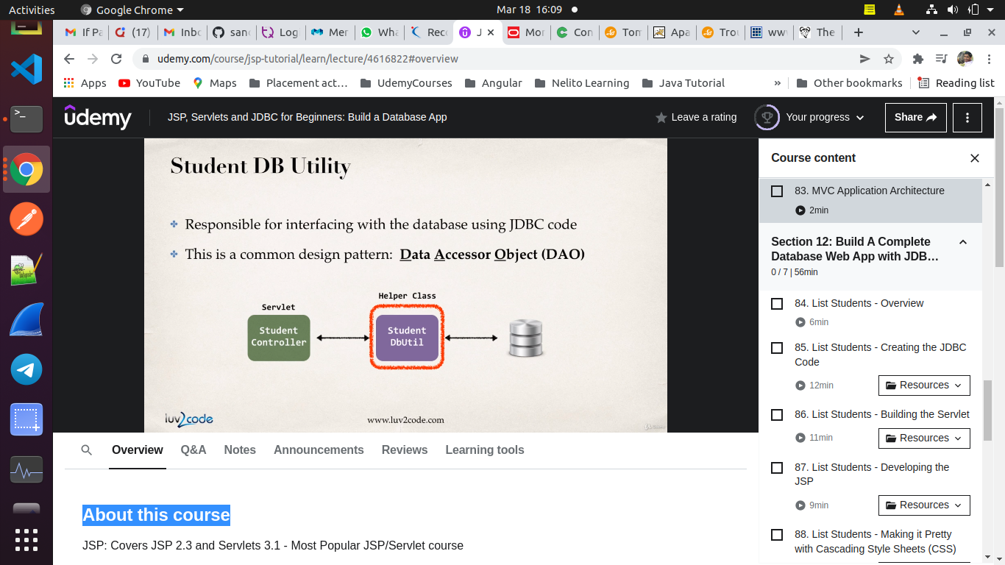
10 ) Create Database application using JSP and Servlet - Part 2 ( List Student )

11 ) Create Database application using JSP and Servlet - Part 3 ( Add New Student )

12 ) Create Database application using JSP and Servlet - Part 4 ( Update Student )

13 ) Create Database application using JSP and Servlet - Part 5 ( Delete Student )
14 ) Apendix
a ) Refresh / Loading Issue
https://en.wikipedia.org/wiki/Post/Redirect/Get
b ) To use bootstrap in the project
https://gist.github.com/anonymous/6ebacea6eebbfa2d08364b26755dd9cf
c ) To secure Web Application
https://docs.oracle.com/javaee/7/tutorial/security-webtier.htm#BNCAS
http://www.avajava.com/tutorials/categories/tomcat
d ) How to hide sensitive data ?
- > GET vs POST
https://stackoverflow.com/questions/198462/is-either-get-or-post-more-secure-than-the-other
-> SSL Configuration
https://www.mulesoft.com/tcat/tomcat-ssl
e ) How to use Maven with JSP project ?
https://maven.apache.org/guides/index.html
f ) To add search feature to web app
http://www.luv2code.com/downloads/udemy-jsp/jsp-student-tracker-bonus-search.zip
g ) To prevent Empty field
http://www.luv2code.com/downloads/udemy-jsp/web-student-tracker-solution-with-form-validation.zip

